AN APPROACH TO SIMULATE FLUID STRUCTURE INTERACTION INVOLVING FREE SURFACE FLOWS

Vom Fachbereich Maschinenbau

an der Technischen Universität Darmstadt

zur Erlangung des Grades eines

Doktor-Ingenieurs (Dr.-Ing.)

eingereichte

Dissertation

vorgelegt von

**Dipl.-Ing. Jessica Marcela Mariño Salguero**

aus Ecuador

Berichterstatter: Prof. Dr. rer. nat. Michael Schäfer

Mitberichterstatter: Prof. Dr.-Ing. #####

Tag der Einreichung: #.#.2020

Tag der mündlichen Prüfung: #.#.2020

Darmstadt 2020

D 17

Abstract

Simulating the interaction of multiphase flows with rigid or flexible structures is of great interest for enhancing the design of marine structures. Another problem is the dependence on a low Courant number to accurately capture the fluid interface, resulting in excessively long computational times. This work overcomes the mentioned problems with a new efficient and stable implicit partitioned fluid-structure interaction (FSI) approach where the fluid calculation is performed with the in-house solver FASTEST, using a finite volume method, while the structural calculation is solved with the CALCULIX program, based on the finite element method. The two solvers are coupled via the PRECICE multiphysics platform. In each time step, the solvers act iteratively, serially or in parallel, the fluid solver receives displacements and sends forces, while the structural solver receives forces and send displacements. The coupling is stabilized and accelerated with quasi-Newton methods, filters, and extrapolation.

The multiphase dynamics are described with the one-fluid formulation of the Navier-Stokes equations and the volume fraction transport equation in the arbitrary Lagrangian-Eulerian (ALE) framework to deal with the moving domain. The fluid interface is captured with an algebraic volume of fluid (VOF) method based on high-resolution schemes implemented through a new modified normalized weighting factor (MNWF) technique that maintains fluid interface sharpness and stability for high Courant numbers (Co > 1). Consequently, FSI simulations can use large time-steps and thus reduce the computational time. Also, dynamic switching between SIMPLE and PIMPLE is applied to achieve high convergence of the pressure-velocity coupling. The new approach is validated considering a dam break with an elastic obstruction as a test case. The simulation results are in accordance with the literature references, and the method shows a positive effect on accuracy, computational time and stability.

ACKNOWLEDGEMENTS

CONTENTS

Table of Contents

**Type chapter title (level 1)1**

Type chapter title (level 2)2

Type chapter title (level 3)3

**Type chapter title (level 1)4**

Type chapter title (level 2)5

Type chapter title (level 3)6

List of Figures

List of Tables

Notation and Nomenclature

1. **INTRODUCTION**

Fluid-structure interaction (FSI) involving free surface flows is a transitory and non-linear multi-physical phenomenon that play a dominant effect in the design and operation of many engineering systems especially in the field of naval architecture, civil engineering, and marine engineering. Since marine structures such as ships and offshore structures are massive and capital-intensive structures placed in an unfriendly environment where the green water effect produced by regular and giant waves can damage them. The wave overturning, breaking and collapse during the initial stage of green water phenomena results in high-frequency vibration of the deck structure that produces damages by fatigue. Additionally, the dropping impact induced by the vast water volume that falls onto the deck can lead to a relatively large structure deformation (Hu, Tang, Xue, Zhang, & Wang, 2017). Consequently, research to better comprehends the interaction of structures with free surface flows, skilled engineers, and efficient design tools are required in order to enhance and optimize the designs of marine structures and prevent damage.

Because this multi-physical phenomenon has no analytical solutions for the most part and laboratory experiments are difficult and expensive to perform. The numerical simulations seem to be a better choice to obtain valuable information about the phenomena with less effort. In the last three decades, several numerical methods have been developed that partially solve the problem. An intensive investigation has focused on creating numerical models that accurately describe the dynamics of free surface water flow around rigid structures (Akkerman, Bazilevs, Benson, Farthing, & Kees, 2012; Pin, Idelsohn, Oñate, & Aubry, 2007), so they have reached their maturity of development. They are now commonly used to solve real industrial applications. For example, in the shipping industry, numerical simulation of flow around a rigid ship moving at a certain speed is used in the design stage to estimate the hydrodynamic resistance of the ship and then minimize it by proper hull-shape design (Wackers et al., 2011). Also, researchers are using these methods to explore alternatives to propeller propulsion, such as fin propulsion (Pedersen, 2015).

On the other hand, the consideration of the structure as a rigid body does not apply to the design of the new generation of large containers. Ultra-large container ships have large open deck areas and thereby highly non-linear wave-induced loading, so hull flexibility plays an essential role in the response of the vessel. For these ships, the hull-beam vibration natural frequencies become as low as 0.40 Hz. They can be continually excited due to the high-frequency components in the wave spectrum and to non-linear excitation effects. So, to calculate the wave-induced load and prevent fatigue damage to the hull, the flexibility of the structure must be considered. Similarly, for offshore structures used for the extraction of hydrocarbons and minerals below the seabed at great water depths or in arctic waters, as well as for sustainable energy production, the flexibility of these floating platforms and their support elements are an important parameter to properly estimate fatigue damages and prevent direct resonance with dominant ocean wave frequencies (Pedersen, 2015). Therefore, the development of consistent, efficient, and stable numerical methods is required to calculate the interaction between waves and flexible structures.

Another critical point is the improvement of hydrodynamic calculation procedures involving flow around the slender bodies which is essential for the development of offshore wind turbines.

However, the numerical methods that describe the interaction between free-surface flows and elastic structure when the deformation is not neglected is still a challenge. Because the two fields describing multiphase fluid dynamics and structural dynamics must be carefully coupled to overcome the instability and decoupling caused by abruptly changing load conditions at the fluid-structure interface which result from the large density differences within the flow domain (Bogaers, Kok, Reddy, & Franz, 2016).

* 1. **Numerical Methods to solve free-surface flows**

In the case of free-surface flows, specifically air-water flows, an essential requirement for the numerical approaches is the robust solution concerning breaking waves. For most practical applications, the exact modelling of the breaking is not necessary. However, the evaluation of the global effect of forces produced by the breaking waves is mandatory. Another requirement is that the methods are stable even at high Courant numbers in order to use practical time-steps and reduce computational time.

The computational methods to describe the interface location and how it moves can be classified into four categories: interface tracking methods, meshless methods, from tracking methods and interface capture methods. The first is preferred for its efficiency and accuracy in solving simple free surface flows, and the other for their applicability for computing complicated and variety problems than included arbitrarily complex geometries. Fig. # illustrated the methods.

|  |  |  |  |
| --- | --- | --- | --- |
|  | | | |
| 1. Interface tracking method | 1. Meshless method | 1. Capture method | 1. From tracking method |

Fig. 1 Techniques to solve the free-surface flow

Interface Tracking Methods (ITM)

The interface tracking methods or fitting methods deform the grid to match each current free surface shape. The interface evolution is directly tracked by the Arbitrary Lagrangian-Eulerian (ALE) method. The free surface is approximated as a mesh boundary that moves influenced by the flow. The pressure of the air is assumed constant, and the viscous stresses in the air are negligible. Then, the jump conditions (no phase-change, no-slip at the interface, and force balance) of the interface become a boundary condition for the liquid domain (Tryggvason, Scardovelli, & Zaleski, 2001).

An advantage of the fitting methods is that the form and location of the free surface is explicitly known, and it is always sharp. Thus, more details of the flow near the wave surface are known, and the accuracy of force computation increases (Hoekstra, 1998). Besides, the ALE method is very suitable for simulating free-surface problems with large deformation of the interface, but no topological changes are present (Wall, Genkinger, & Ramm, 2007). The method has difficulty in addressing topology changes generated by breaking waves, overturning, or splashing. The strong deformation or topological changes of the interface lead to a degeneration of the computational mesh, and the remeshing techniques are also an additional source of errors. For this reason, in industrial applications, it is usually applied for prediction of steady flow around ship hulls or flows with mild breaking only (Wackers et al., 2011).

Meshless methods

Particles are used to track the movement of the interfaces. The grid that they form may be adapted to account for any changes in the interfacial shape (Unverdi & Tryggvason, 1992). A successfully approaches are the Smooth Particle Hydrodynamics (SPH) method that accurately solves free surfaces, or the Moving Particle Semi-Implicit Method (MPS) (Koshizuka & Oka, 1996).

From tracking methods

The interface location is approximated as surface mesh, and its evolution is directly computed by Lagrangian advection of the discrete points located on the interface. The level set (LS) methods (Osher & Fedkiw, 2001; Osher & Sethian, 1988; Sussman, Smereka, & Osher, 1994) form this category. In the level set methods, the subdomains occupied by water and air are designated as negative and positive values of a hyperbolic scalar function denominated as level set function and the set of discrete points located on the interface as the zero-level set function. Thus, the level set function is a signed-distance function, its magnitude represents the distance from a point in space to the interface, and its sign determines if the point is in water or air domain (Akkerman et al., 2012). The motion of the interface is determined with the advection of the level set function, which often gets irregular and must be reinitialized to maintain physical results. In the field of water-air problems, the level set methods are divided into two-phase and single-phase approach. The two-phase approach solves both water and air regions. In contrast, the single-phase approach only computes the water region, and the air region is extrapolated using the free surface boundary condition (Hino, 2006). The second approach is nowadays most used because it requires less computational time.

The benefit of the level set methods is that they always compute an explicit sharp interface and can model topology changes of the free surface. Hence, they are sustainable for use in the case of strong breakings. Although the method is not inherently mass conservative and demand surface tension treatment. It is commonly believed that the advection of the level set function and re-initialization of the interface are the main sources of the problem (Bai, Avital, Munjiza, & Williams, 2014).

* 1. **Capture Methods**

In these methods, the flow interface is not explicitly known and appears as a numerical discontinuity of an indicator function. The classical volume of Volume-of-Fluid (VOF) method (Hirt & Nichols, 1981) belongs to this category. The VOF is based on the so-called Marker-and-Cell approach. A scalar indicator function called volume fraction determines the spatial distribution of the two fluids. The volume fraction tracks one of the fluids and takes values between zero and one. A value of one denotes presence and zero denotes absence of the traced fluid. A volume fraction between zero and one indicates the presence of a mixture, and the value of 0.5 defines the interface between the fluids. A significant advantage of this formulations is that only a transport equation for the volume fraction must be solved to determine the proportion of fluid in each cell.

Nevertheless, the accuracy of this approach depends on the discretization advection schemes. It should ensure a monotonic change of the volume fraction (boundedness) and reduces the numerical diffusion and dispersion near the interface. In the 80s, some approaches such as PLIC (Lötstedt, 1982) and SLIC (Ashgriz & Poo, 1991) were employed. They represented the interface geometrically and were limited for structured grid discretization. Later in the 90s, Davis (Davis, 1994) introduced a more practical approach. The convection of the contact discontinuity by higher-order blended discretization schemes. He proposed a combination between a less diffusive scheme, which reduces the smearing of the profile, and a compressive scheme, which removes any diffusion near the interface. This idea has been employed to develop several blending advection schemes, also known as interface-capture schemes, for example, CICSAM (O. Ubbink & Issa, 1999), HRIC (Muzaferija & Peric, 1998), IGDS (Jasak, Weller, & Gosman, 1999), STACS (Darwish & Moukalled, 2006), BICS (Queutey & Visonneau, 2007), FBICS (Tsui, Lin, Cheng, & Wu, 2009), and others. The blending strategy takes into account the angle between the flow direction and the grid lines.

The VOF method is robust to handle complex free surface such as overturning or breaking waves and splashing. It solves most of the problems in naval hydrodynamics, e.g. still-water resistance, wave diffraction and free motion problems (Wackers et al., 2011). Besides, VOF is mass conservative, applicable for structure and unstructured grids.

These methods demanding surface tension treatment.

At the same way, different approaches have been developed for tracking the interface. One example is the interface capturing method: Volume-of-fluid (VOF) where the volume fraction of each fluid is tracked through every cell in the computational grid. It presents an inherent mass conservation but parasitic currents exist. The interface tracking method represents explicitly the interface and has an accurate approximation of the surface tension, nevertheless the algorithms are highly complex. In this category, the most popular is Arbitrary Lagrange-Eulerian (ALE). And finally, there are front tracking methods which approximate the interface explicitly with accurate interface advection but do not conserve mass and also present parasitic currents. One of them is the level set method (LS). Several authors have tested the advantages and shortcomings of each method, and also have improved them. For instance, Sun simulated the OC3-Hywind floating wind turbine using an ALE technique combined with the level set method to approximate the free flow surface (Sun, Djidjeli, Xing, & Cheng, 2016). Yan found that the breaking waves have a violent flow that can be simulated employing a Moving Particle Semi-implicit (MPS) method (X. F. Yang, Peng, & Liu, 2014). Basting develops a hybrid level set-front tracking approach suitable for FSI and free surface flows (Basting & Weismann, 2013). Akkerman simulated a Ship Navy combatant, so that the author tracked the fluid-structure interface and captured the air-water interface employing a mixed Interface Tracking/Interface-Capturing Technique (MITICT) (Akkerman et al., 2012). Del Pin used a Particle Finite Element Method (PFEM) for the free surfaces and fluid-solid contacts, while an ALE formulation was employed in the rest of the domain (Pin et al., 2007).

**Surface tension: For the numerical treatment of the surface tension force the Continuum- Surface-Force-Method (CSF)** (Brackbill, Kothe, & Zemach, 1992) **is used in this thesis, which extends the surface force to a volume force** (Staab, 2016)**.**

* 1. **Review of numerical methods for flows with moving interfaces**

In general, there is two main approach to model FSI problems, the monolithic approach or partitioned approach. The monolithic approach solves the fluid, structure, and interface equations simultaneously in a single and specialized solver.

, and (Walhorn et al., 2005) performed a monolithic model for FSI combined with the level set method (LS) to track the free surface. In contrast, the partitioned approach uses separate field solvers that solve the fluid dynamics and the structure dynamic in an iterative process and explicitly uses the interfacial conditions to relate information between fluid and structure solutions. The monolithic methods generally are more strong and sometimes more efficient than partitioned schemes (Degroote, Bathe, & Vierendeels, 2009). However, the formulation must be adjusted to each problem, so it is less versatile than the partitioned approach. For this reason, nowadays, the partitioned approach is the most applied approach due to its modularity and the possibility of re-using existing software. For example, Schäfer proposed an implicit partitioned approach between the fluid solver FASTEST and structural solver FEAP through coupling interface mpCCI (Michael Schäfer, Heck, & Yigit, 2006). Also, (Kassiotis, Ibrahimbegovic, & Matthies, 2010) developed a partitioned approach coupling FEAP for the structure and OpenFOAM for the fluid. (Paik & Carrica, 2014) created a partitioned approach that uses the gluing method to transfer the forces and displacements on non-matching grids for fluid and structure domains.

* 1. **State oft the art**

(Nicolici & Bilegan, 2013) verified that the sloshing dynamic load in a tank can be feasible evaluated with a bidirectional FSI coupling. While with the one-way coupling model underestimates the base shear forces. The coupling platform was Ansys Multi-Field (MFX). The CFX software solved the hydrodynamic equations and finite element solver, Mechanical, solved the structure part.

The offshore wind turbines are a problem into the framework of FSI and free surface flow. simulated the OC3-Hywind floating wind turbine with a non-spinning rotor. He discretized the fluid part with ALE technique combined with the level set method to approximate the free flow surface between the two incompressible flows, water and air. A combination of the Lagrangian formulation (finite element method) and isogeometric analysis (IGA) was used. The fluid domain was discretized employed an FEM based moving domain ALE technique, while the IGA-based rotation-free shell and beam formulation is employed to model the structure. The free surface phenomena are modeled with the level set method (Yan, Korobenko, Deng, & Bazilevs, 2016).

(Prasad, Hino, & Suzuki, 2015) simulated the flows around shallowly submerged hydrofoil moving steadily under the free surface to compute lift and drag forces. The author used a commercial mesh generated to represent the topology, the fluid domain was formulated using finite volume method incorporated with VOF using an OpenFOAM software. The fluid around the hydrofoil was considered turbulent flow and was solved taking account k-\epsilon model. Finally, the simulation was compared with the experimental date.

(Sun et al., 2016) found that the braking waves is violent flow that can be simulated employing a Moving Particle Semi-implicit (MPS) with some remedies to avoid the disorder particles distribution, which lead to inaccurate results. They coupled MPS Moving Particle Semi-implicit (MPS) with modal superposition methods for simulating and tested that this method is quite suitable for nonlinear water-structure interaction of the marine structures, which involving large rigid motions with small elastic structure deformation.

(Paik & Carrica, 2014) develop a partitioned approach that uses the gluing method to transfer the forces and displacements on non-matching grids for fluid and structure domains. A linear FEM solver is applied to deform the outer boundary of the boundary layer grids which wrap around the deformable geometries. The deformation of interior points in the boundary layer grid is obtained using linear interpolation. The testes were over three cases of rolling tanks partially filled with fluid with an elastic bar clamped to bottom or top.

(Bai et al., 2014) captured the fluid structure interaction and free surface flow to predict the power performance of a marine current turbine. In this work, the free surface was considering a moving boundary with a single-value height function calculated and updated using a kinematic boundary condition.

(Basting & Weismann, 2013) develop a hybrid level set-front tracking approach suitable for FSI and free surface flows. The method can be implemented over an existing ALE formulation to enhanced geometrical flexibility so the mesh is automatically aligned to the geometry providing an explicit description of interfaces. Then, the curvature can be evaluated easily. Furthermore, the set function maintains the mesh connectivity and optimize the mesh generation using aligned triangulations to the geometry to obtain a discrete interface reconstruction of higher order and explicit representation. Consequently, due to the fixed mesh connectivity, ALE was implemented without remeshing and interpolation. This approach was tested for simulating a FSI and a two-phase problem, the cardiac valve in 2d and 3d and stationary bubble respectively.

(Pin et al., 2007) analyzed two incompressible flows in contact with the solid face using the Particle Finite Element Method (PFEM) for the free surfaces and fluid–solid contacts, while an ALE formulation was employed in the rest of the domain.

(Walhorn et al., 2005) performed a monolithic model for FSI combined with the level set method to track the free surface. The capture of the discontinuities at the interface was through of modification of the ansatz function.

(M Schäfer, Sternel, Becker, & Pironkov, 2011) treat the FSI problems using a partitioned code where the finite volume method involving an ALE formulation is implemented in the research software FASTEST to solve the flow, and FEAP is a finite structural solver. The two solvers are coupling with MpCCI. The Flow was partitioned multigrid to accelerate the process. The grid deforms in three steps. First, the block edges distort, second the faces distort and finally the current condition of the faces is the boundary conditions to distort the internal grid.

(Kassiotis et al., 2010) used a partitioned approach coupling FEAP for the structure and OpenFOAM for the fluid. FEAP is a Lagrangian way and solved the structure deformation by finite element method. OpenFOAM is based in finite volume discretization and use the VOF strategy formulated in an ALE framework to solve the free-surface flow.

The complete mathematical framework and well stablished convergence properties. Meshed Lagrangian approach is used to represent the free surface fluid flows by using constant remeshing; therefore, efficient mesh generators are needed in order to compute the new topology at each iteration. (Kassiotis et al., 2010)

(Akkerman et al., 2012) used a mixed Interface Tracking/Interface-Capturing Technique (MITICT) to track the fluid-structure interface and to capture the air-water interface on a Ship DTMB 5415 Navy combatant at lab scale in head waves of large amplitude problem. The air-water interface was handled by Level set function, and the fluid-rigid body interface used the interface tracking ALE. The coupled FSI-Free surface problem was made with a midpoint time integration algorithm. He assumed that the complex structure is a rigid object.

Another example of strong free surface flow interaction with a structure is the phenomena of liquid sloshing in storage tanks. For instance, in partially filled tanks of automobile or aeroplanes, as well as, in the huge LNG shipping containers, the resonance periods of swaying motions induce sloshing that lead in some situations to anchorage failure.

The deformation of the insulation system in huge containers of LNG have been estimated (Lee et al., 2013). The FSI case was carried using a coupling FEM-ALE method formulation. Likewise, the offshore structures used for the sustainable-energy production and extraction of hydrocarbons from deep water are huge floating platforms that support impact forces on the horizontal members in the splash zone due to contact with the crests of incident waves (Kaplan, 1992)

In partitioned fluid-structure interaction problems, the solvers act as black-boxes with a given input-output relation at the common boundary. Regularly, the fluid solver receives velocities as an input and returns forces as an output. The structure solver takes forces as an input and returns displacements. The coupling conditions between flow and structural equations are not part of a large system of the fluid or structural equations (Mehl et al., 2016). The classical method to couple fluids and structures solvers is a staggered execution: in each new iteration, the velocity and boundary position calculated from displacements are prescribed in the fluid solver, then it calculates the pressure that is transferred to the structure solver as a surface load on the interface fluid-solid in the structure domain to solve the displacement. The convergence occurs when the difference between the velocities of the fluid and the solid boundary is less than the acceptable error. Serial execution of the coupling becomes often slow, the parallel implicit coupling can overcome the problem (Mehl et al., 2016).

Usually, the structure domain is formulated in a Lagrangian framework, which solves the structure deformation by finite element method (FEM) whereas the fluid domain is discretized with special methods as Arbitrary Lagrangian-Eulerian (ALE) formulation or the Immersed Boundary/Body (IB) owing to that the fluid domain has an unsteady movement. For example, Akkerman et al. (Akkerman et al., 2012) studied the behavior of a rigid combat ship at lab scale in head waves of large amplitude. The air-water interface was handled by Level set function, and the fluid-rigid body interface used the interface tracking ALE. The simulation predicted large-magnitude sloshing, which was unphysical and not coincided with the experimental data. This was due to the large time step size that provokes an instability in the simulations. Similarly, Wang (Wang et al., 2017) presented a partitioned FSI method based on the penalty immersed boundary method IB to calculate the large deformation produced by shock waves.

The interface solid-fluid is a moving boundary that follows the deformation of the structure, and the whole grid inside the fluid domain follows the interface movement (Kassiotis et al., 2010). ALE algorithm is robust for small movements of solids, but when dealing with large deformations or displacements of solids can cause numerical instabilities (P. Yang et al., 2016) and degeneration of the computational mesh. Also, ALE presents difficulties when the free surface undergoes very large motions with the breaking of waves and fluids leaving a container (You & Bathe, 2015). In these cases, the remeshing techniques are used to overcome this problem, or also ALE is combined with the level-set function to enhance the geometrical flexibility (Basting & Weismann, 2013). For large mesh motions, the immersed body method is suggested (P. Yang et al., 2016).

**FSI METHODS**

For coupling the fluid and the solid equations, the boundary fluid and solid velocities are the same. To linearized both subsystem a Gauss-Seidel process can been chosen. (Pin et al., 2007)

In each k+1 iteration, the fluid solver obtains the velocity, pressure and position in function of the previous values of the iteration k and the velocity and position of the structure extracted of the solid solver. The same way, the solid solver computes the new velocity and position using the previous values and the information of the velocity, pressure and position computed in fluid solver. The expressions are the followings

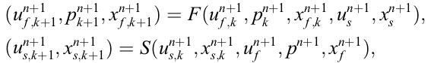

The convergence occurs when the difference between the velocities of the fluid and solid boundary is less than the acceptable error.

The FSI problems solved using Lagriagian-ALE have two advantages compared with the full Lagrangian formulation. No distortion due to vortexes is observed in the mesh and the time step in the ALE case is over 50% larger than in the Lagrangian case. (Pin et al., 2007)

Where the fluid and structural dynamics is discretizing using the finite element method, and the space-time formulation is in solved simultaneously in a single step. In the FEM formulation, the Dirichlet boundary conditions in the fluid are the velocity values, which are the structural velocities, and the fluid load boundary are considered as surface loads on to the structure.

The partitioned methods are preferred for its modularity and the possibility of re-using existing software. (Kassiotis et al., 2010)

The main trouble for the partitioned approach is the data exchange between the solvers and the low convergence rate. For strongly coupled FSI, a sub iteration process should be set up for every time step, but to achieve convergence, typically quite a lot of subiterations are required. When exist a lot of iterations between both subproblems, this approach can lead to divergence in the subiteration process. The use of constant underrelaxation can avoid the divergence but convergence is not really obtained (Vierendeels, Lanoye, Degroote, & Verdonck, 2007). Therefore, other more effective techniques have been developed to accelerate and stabilize the partitioned coupling, some of them are the Aitken-like acceleration method (Mok, D.P., Wall, W.A., & Ramm, 2001), the approximating the system interface Jacobians (Fernández & Moubachir, 2005) or the fixed-point iteration with dynamic relaxation (Küttler & Wall, 2008). The most relevant for the last category are the quasi-Newton inverse least squares method (QN-ILS) (Vierendeels et al., 2007) and the Multi-vector iteratively updated quasi-Newton (MVQN). The QN-ILS improves the performance by including information from previous time steps but the optimal choice of how many time-steps has to be included is problem dependent. Thus, the appropriate parameter is obtained after several testing. The QN-ILS approximation needs at least two iterations. To avoid large initial divergence, a relaxation factor is applied at the first iteration of the first time-step. (Bogaers et al., 2016) The MVQN removes the necessity of select parameters, and has superior convergence behavior.

For example, Schäfer (Michael Schäfer et al., 2006) developed an implicit partitioned solution approach. It couples the finite volume flow solver FASTEST, the finite-element structural solver FEAP using the coupling interface MpCCI. For each time step, the fluid-structure coupling is performed by a predictor-corrector iteration process that is stabilized by under relaxation. Whereas, Liao, Hu, and Sueyoshi (Liao, Hu, & Sueyoshi, 2015) use the finite difference method (FDM) for the flow part and the Finite element method (FEM) for the structural part. They computed the dam break hitting an elastic structure and presented the comparison with their experimental results.

Other authors prefer the coupling partitioned implicit free surface. worked in a full Lagrangian framework to discretization the flow and structure field. The flow was considered incompressible and was analyzed using ALE formulation. The mesh displacements is determined by solving the elastostatic system of equations (linear elasticity under the conditions of equilibrium, in which all forces on the elastic body sum to zero, and the displacements are not a function of time). The domain was divided in internal and boundary domain close to the free surface. Only the free surface position or the mesh velocities on the boundary are unknowns in the fluid solver.

ALE (Arbitrary Lagrangian–Eulerian) method

In FSI problems the fluid domain has a unsteady movements, so that the interface solid-fluid follows the deformation of the structure. A classical fixed Eulerian grid is not useful for this work. To overcome this difficulty the ALE formulation is apply, where the whole grid is moved inside the fluid domain following the movement of the boundary. However, the unknowing the new shape of the boundary is a new inconvenient. The mesh motion problem is analogy to a solid body under large deformation, consequently the problem is solved using solid equations and linking each point of the mesh by a fictitious spring. (Kassiotis et al., 2010)

As a result, the fluid domain is discretized in a coordinate system  that considers the position of the structure after the deformation, but  dependents of the undeformed reference coordinate system of the structure . The two coordinate systems are related by the deformation gradients matrix , which contains the derivative of each component of the deformed  vector with respect to each component of the reference  vector.

Using the definition of the deformation gradients , any scalar variable as the pressure can be referred to the undeformed coordinates as,



In the case of viscous terms, the classical Piola transform is used to obtain the term in the reference coordinate system,



here J is the Jacobian of the deformation (determinant of matrix ). Then the viscous terms may be expressed in the deformed configuration as:



Then, the final ALE formulation which describes the dynamics of a viscous, incompressible fluid can be written as





After the deformation of the structure, the fluid mesh needs to be rebuilt. One methodology to rebuilt is the elliptic grid generation which distorts the grid in three steps: first the block edges distort, second the faces distort, and finally, the current condition of the faces are the boundary conditions for the distortion of the internal grid (M Schäfer et al., 2011) . To extend satisfactory the 2D elliptic grid generator to 3D geometries, some additional boundary constraints for the mesh equations are necessary (Fraggedakis, Papaioannou, Dimakopoulos, & Tsamopoulos, 2017).

* 1. **Motivation**

**About problems related to fsi and multiphase**

* 1. **Scope and Objectives**

To development, to investigate and to apply of computational methods that allow for a reliable simulation of fluid-structure interactions involving free-surface flows with high numerical efficiency.

As the first part of my doctoral project, the multiphase code was extended to support moving grids. However, the standard VOF version in combination with the FSI approach lacks stability and consistency. Therefore, the major objective of my research project is the development and application of new computational methods that allow a reliable simulation of fluid-structure interactions involving free-surface flows with high numerical efficiency.

Despite several approaches have been developed to predict the fluid-structure interaction in the context of multiphase flows, there are still many challenges to combine the two fields and to simulate more complex real systems, mainly because the solving algorithms show some limitations in getting stable and accurate results when second order derivatives are involved in the governing equations.

Therefore, the major objective of this Ph.D. project is to develop, investigate, and apply computational

methods that allow a reliable simulation of fluid-structure interactions involving free-surface flows with high numerical efficiency.

The problem will be focused on a partitioned FSI approach. On the one hand, the fluid-dynamics will

be solved in a multigrid solver FASTEST where the domain is discretized using finite volume method (FVM) and block-structured meshes. On the other hand, the solid part will be computed with a finite element method (FEM) in the solver FEAP. The two solvers will be coupled with a serial implicit method in the multiphysics environment preCICE. Consequently, the specific research aims of this project are:

• Modify the Arbitrary Lagrange-Eulerian formulation (ALE) already implemented in FASTEST to the

case of multiphase flows.

• Implement the Immersed Boundary method (IB)in the solver FASTEST.

• Analyze and compare the ALE and IB techniques in the multiphase framework in order to improve

these methods.

• Fix the currently implemented coupling Volume-of-fluid with the Level-set method used to track

the multiphase interface, and extent it to 3D.

• Perform systematic investigations of the efficiency and the accuracy of the implementations for

selected test cases. This will provide insight into the capabilities of these methods for dealing with

complex real-world applications.

* 1. **Outline**

1. **MATHEMATICAL MODEL**

**abstract**

* 1. **Fundamental equations of the flow dynamics**
* **Continuity equation**
* Navier-Stokes equations
* One-fluid formulation
* Volume-fraction transport equation

FLUID STRUCTURE INTERACTION AND FREE SURFACE:

It is normal to follow material point motion in a Lagrangian formulation while a Eulerian formulation is often preferred for the fluid part. (Main & Farhat, 2014). When the system of interest includes rigid or deformable bodies that undergo large motions and/or deformations, each such body is modeled here in a Lagrangian.

CASES OF FLUID ANALISYS:

According moving reference frame (referencia movil):

1. The moving reference frame moves with the particle, it is Lagrangian formulation.
2. The moving reference frame is fixed in space, the full Eulerian formulation is achieved.
3. The moving reference frame moves with an arbitrary velocity, then the ALE formulation is retrieved

Methods:

1. Smooth Particle Hydrodynamics (SPH) Method: The advantage not to necessary the remeshing step.
2. Meshless Finite Element Method (MFEM)

We consider a free surface flow interacting with an elastic structure. Thus, the domain of this problem consists of a two-phase fluid domain and a structural domain denoted by Ωf and Ωs, respectively. The fluid-structure interface  is the boundary where the flexible structure interacts with the fluid.

Two-phase fluid domain

The fluid domain uses the Arbitrary Lagrangian-Eulerian method where the moving reference frame moves with an arbitrary velocity. The fluid domain in FSI problems has an unsteady movement, so that the interface solid-fluid follows the deformation of the structure. A classical fixed Eulerian grid is not useful for this work. To overcome this difficulty the ALE formulation is apply, where the whole grid is moved inside the fluid domain following the movement of the boundary. However, the unknowing the new shape of the boundary is a new inconvenient. The mesh motion problem is analogy to a solid body under large deformation, consequently the problem is solved using solid equations and linking each point of the mesh by a fictitious spring. (Kassiotis et al., 2010)

The fluid domain involves the incompressible flow of two viscous, immiscible, and isothermal Newtonian fluids. The two phases are modelled as one fluid with variable material properties that change abruptly at the phase boundary. Therefore, the set of governing equations that described the phenomenon are the one-fluid formulation of the mass and momentum conservation equations, and the volume fraction transport equation. To deal with the moving domain, they are written in the Arbitrary Lagrangian-Eulerian (ALE) framework as







where ***u*** is the fluid velocity, ρ the density,**u***g* the grid velocity due to the displacement of the structural part, ***T*** the stress tensor, ***g*** the gravitational force, and *α* the volume fraction of one of the fluids. and the last term represent the surface tension that is the product of the constant surface tension coefficient σ, characteristic for the combination of fluids, and the Gaussian curvature $κ$, defined by the divergence of the vector normal to the interface. The surface tension is a line force acting in normal direction to the interface due to the cohesion between molecules within one phase. This force induces pressure differences between the two phases and represents the differences of stress tensors between both fluids. The surface tension is dominant if the curvature radius of the interface is small, for example, in a water droplet. Instead, if the curvature radius tends to infinity, as the water in a lake, this force is negligible.

For Newtonian incompressible fluids, the stress tensor is assumed to be a linear function of the rate of strain and is defined with the Stokes law as



where μ is the dynamic viscosity, *p* the pressure, and **I** the unit tensor.

To derive the momentum equation of the multiphase system, this is considered as a single continues domain  with a jump across the interface . Furthermore, no mass transfer in direction normal to the interface, and no-slip condition are assumed, with this in mind, the normal velocities at the interface are equal but opposite, , and the tangential velocity is the same, . Fig. 13.1 shows the system.

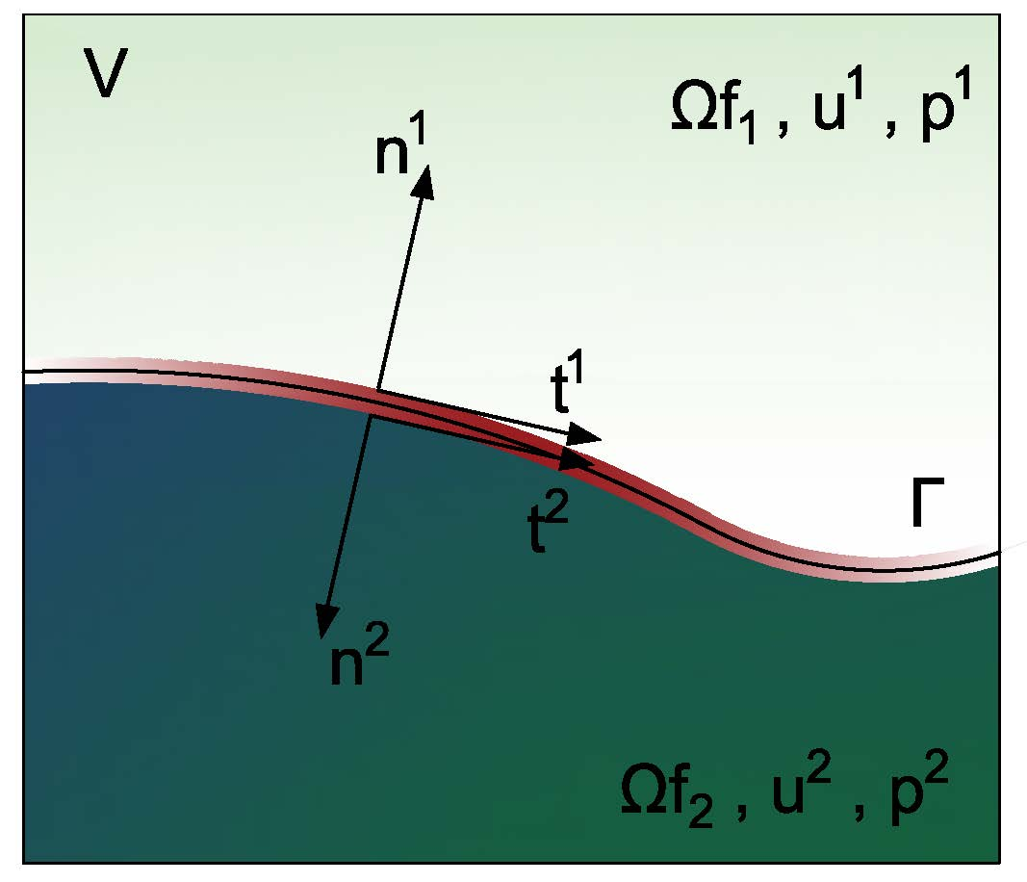

Figure 3.1 Control volume *V* with interface  between two fluids.

The jump at the interface produces a surface tension . The surface tension is a line force acting in a direction normal to the interface due to the cohesion between molecules within one phase which causes boundedness forces that induce pressure differences between the two phases, and also minimize the surface area of the interface. Hence, the surface tension is a new force term in the NSE in one fluid formulation because of the differences of stress tensors between both fluids, and is expressed as,



where is the constant surface tension coefficient, characteristic for the combination of fluids, and the Gaussian curvature, defined by the divergence of the vector normal to the interface.

At this point is important to know the position and shape of the interface which can be estimated employing different techniques. For example the Eulerian methods: Volume-of-fluid (VOF) (Hirt & Nichols, 1981), level set method (LS), or Arbitrary Lagrange-Eulerian method(ALE) (Sussman et al., 1994).

The normal direction of the fluid interface is found with an indicator function, , solving an additional volume fraction transport equation. This approach can ensure mass conservation but does not accurately capture the interface shape, especially in three-dimensional problems (You & Bathe, 2015) and/or complex interface shapes. In order to attain accurate results, this can be combined with level-set method (MCLS) (van der Pijl, Segal, Vuik, & Wesseling, 2005). This combination exploits the accurate interface reconstruction of the LS and the conservation property of the VOF.

Then, employing the indicator function, the surface tension is reformulated as a volume force and is added to the term  of the NSE (Wacławczyk, 2007):



Now,  depends also on the interface shape. When the radio of the curvature of the interface tends to infinity, the curvature tends to zero, and the surface tension vanishes. Whereas for the case of a small water droplet, the surface tension is dominant, and the gravity force is neglected.

Finally, the NSE used to describe the flow of the multicomponent, viscous, and incompressible fluid are:





here the superscript k was omitted to simplify the equation.

### Curvatures models

In the surface tension term, the most difficult task is to determine the Gaussian curvature  because in the VOF method, the position of the interface is not explicit, and the curvature is approximated using higher order derivatives. For the case of 2D, the equation to determine  is:



Where , , are the higher order derivatives and and are the component of the vector normal to the interface.

The following is a short description of some curvature models already implemented in the FASTEST solver. Everyone employs a different methodology to calculate the higher order derivatives. (1) The Convolution-Methods mollifies the volume-fraction-function with a kernel function and approximate the first and second derivatives using the mathematical properties of the convolution (Aleinov & Puckett, 1995). (2) Standard Finite-Difference-Methods (SFDM) (Michael Schäfer, 2006). It is faster than the convolution technique because only the neighboring cells are considered. However, it tends to show an oscillating behavior at steep gradients. (3) Continuum-Surface-Forces (CSF) smooths the volume fraction before to apply the SFDM \cite{brackbill1992continuum}. (4) Hight-Function-Method (HFM) is a geometrical method that subdivides every control volume in 3xN stencils where three heights related to the interface are found, and with them the curvature in the center of the control volume is computed. (5) The Local-Radius-method (LRM) uses the SFDM for the first derivative after constructs a delta-function and localizes geometrically three points near the interface to compute the local curvature (Staab, 2016).

Also, since the material properties, density and viscosity, vary from one fluid to the other. The average values are evaluated as a function of the volume fraction and individual material properties of each constituent fluid. The average density is recovered from the volume fractions by



that is an algebraic statement of local mass conservation. Whereas, the averaged viscosity is a function of volume fraction, interface orientation, and local fluid velocity:



The above function is derived from considerations of continuity of Newtonian stress across the interface and is applicable for high viscosity ratios across between the fluids (e.g., > 100%) (Kothe, 1998). The details of the deriving a proper average viscosity is good detailed in (Tryggvason et al., 2001). The harmonic mean (Patankar, 1980) favors the fluid with the smaller viscosity, whereas the geometrical mean favors the fluid with higher viscosity. When the the both



Finally, notice that the momentum equation (Eq. 3) is given in the non-conservative form. Because when the density changes abruptly, the conservative form can lead to certain numerical difficulties (Tryggvason et al., 2001).

* 1. **Elastic structural domain**

The solid domain is analyzed into the Lagrangian criterium, where the moving reference frame moves with the particle. The equation of momentum for the solid domain can be represented as

$$ρ_{s}\frac{∂^{2}u_{i}}{∂x^{2}}=\frac{∂σ_{ij}}{∂x_{j}}+ρ_{s}f_{si}$$

Where $u_{i}$ is the displacement, $σ_{ij}$ is the Cauchy stress tensor and $ρ_{s}$ is the density of the solid, and $f_{si}$ is the external volume forces (e.g., gravitational forces). The displacement can be translation and rotation. In many cases the model equation St. Venant-Kirchhoff material is employed.

The material is specified by giving the Cauchy stress tensor σs by the following constitutive law for the St. Venant-Kirchhoff material



the Lagrangian Written



The structure is assumed to be elastic and compressible. These conditions are described by the Lagrangian description with respect to the initial reference state ΩS



Where  is the deformation gradient tensor.

* 1. **FSI coupling**

The problem is closed by Boundary and interface conditions. On solid and fluid boundaries  and standard conditions as for individual solid and fluid problems can be prescribed.

To satisfy the dynamic and kinematic conservation along the interface , the interface stress and displacement are conserved,



where  is the fluid velocity along the interface.

The interface load and motion transfer are performed employing radial basis function (RBF) interpolation. The consistent condition is applied to displacements transfer and conservative condition for forces transfer. The consistent mapping assures that the value at coarse node is the same as the value at the corresponding fine node. Use for normalized quantities e.g. temperature or displacement. In contrast, for conservative mapping, the value at a coarse node is computed as an aggregation of the corresponding fine nodes. Thus, it is required for absolute quantities e.g. force, mass, etc. The RBF interpolation requires no grid connectivity information and is a elegant form to transfer information along non-matching interfaces, between a linear finite volume mesh to higher-order finite element mesh

(Turek & Hron, 2006)

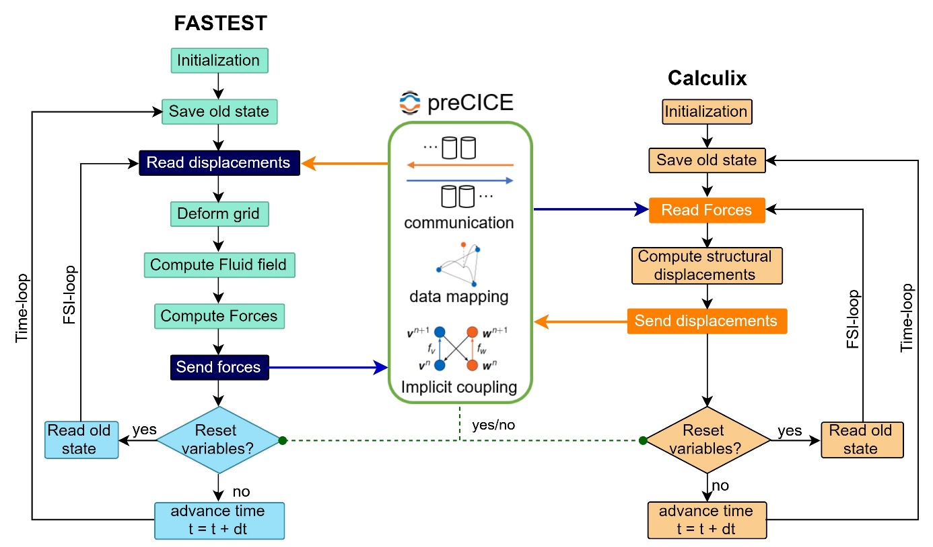

**Figure 1**: Page layout

I work with an implicit partitioned fluid-structure interaction (FSI) approach. We work with an implicit partitioned fluid-structure interaction (FSI) approach proposed by Schäfer and Teschauer (2001). This has been tested and optimized in order to obtain efficient simulations of fluid-structure interaction (FSI) problems with one fluid (Sternel, Schäfer, Heck, & Yigit, 2008; Yigit, Heck, Schäfer, & Sternel, 2007; Yigit, Sternel, & Schäfer, 2007). In a partitioned approach, the solvers act as black-boxes with a given input-output relation at the common boundary. Regularly, the fluid solver receives velocities as an input and returns forces as an output. The structure solver takes forces as an input and returns displacements. (Mehl et al., 2016).

The fluidic computation is performed in the in-house FASTEST solver, employing a finite volume method on hexahedral block-structured grids. While the structural computation is solved with the CALCULIX program, based on the finite element method. The two solvers are coupled in the PRECICE (Bungartz et al., 2016) multiphysics platform.

In each time step, the solvers act in a sequential manner based on the application of a nonlinear iterative method to achieve the multidisciplinary solution. First, the fluid field is solved with an assumed interface location. Second, the resulting fluid pressure and stress are applied to the structure as external forces. Third, the structural part is computed to update the deformation of the structural surface. Fourth, the fluid mesh is distorted to follow the new interface location. The fluid domain follows the interface movements via the arbitrary lagrangian-eulerian (ALE) method and fulfills the Space Conservation Law to not introduce artificial mass sources. Finally, if the convergence criteria of displacement and forces in not achieved, the process is repeated (Hou, Wang, & Layton, 2012).

I work with an implicit partitioned fluid-structure interaction (FSI) approach proposed by Schäfer and Teschauer (Michael Schäfer & Teschauer, 2001). In a partitioned approach, the solvers act as black-boxes with a given input-output relation at the common boundary. Regularly, the fluid solver receives velocities as an input and returns forces as an output. The structure solver takes forces as an input and returns displacements (Mehl et al., 2016). In this case, the fluid part is solved with the in-house solver FASTEST employing a finite volume method on hexahedral block-structured grids. The structural part is solved with the program FEAP (Taylor, 2000) based on the finite element method. The two solvers are coupled in the Multiphysics platform PRECICE (Bungartz et al., 2016). This approach has been tested and optimized to obtain efficient simulations of fluid-structure interaction (FSI) problems with one fluid (M Schäfer et al., 2011) but has not yet been coupled and tested with multiphase flows.

The method to couple FASTEST and FEAP is a parallel implicit coupling to avoid the often slow simulations produced by the serial execution of the coupling reported by Mehl et al. (2016). In each new iteration, the velocity and boundary position calculated from displacements are prescribed in the fluid solver. Then it calculates the pressure that is transferred to the structure solver as a surface load on the fluid-solid interface in the structure domain to solve the displacement. The convergence occurs when the difference between the velocities of the fluid and the solid boundary is less than the acceptable error. In the next paragraphs, we describe the process of the FASTEST program to solve the fluid problem. Although the coupling algorithm, the structural analysis, and the method to adapt the fluid domain are an important part of the topic, we do not go into detail about this topic. More information can be found in (Michael Schäfer et al., 2006).

In the case of a multiphase system, the Volume of Fluid method (VOF) developed by Hirt and Nichols (Hirt & Nichols, 1981) is used due to the guaranteed mass conservation and the possibility of simulating complex free surface flows. The VOF method introduces an additional transport equation for the volume fraction α that captures the position of the interface between the two fluids. The standard VOF implementation in the program FASTEST uses the High-Resolution (HR) scheme M-CICSAM (Wacławczyk, Caner Gemici, & Schäfer, 2007) to advect the volume fraction in space. The HR scheme is incorporated in the discretized equation through the Downwind Weighting Factors (DWF) method of Leonard and Mokhtari (Leonard & Mokhtari, 1990). The drawback of this implementation is strongly dependent on the Courant number (Co) (Hoekstra, Vaz, Abeil, & Bunnik, 2007). M-CICSAM scheme keeps the sharpness of the interface and is stable for Co less than 0.5 using very small time-steps.

The simulation of the two viscous, incompressible, and immiscible fluids in a moving domain is based on the one-fluid formulation of the Navier-Stokes equations and the VOF equation defined in the Arbitrary Lagrangian Eulerian description (ALE). Where the convective term of the equations is multiplied by the relative velocity that is the difference between the fluid velocity and the grid velocity. The grid velocity is produced by the structural deformation and is calculated using the Space Conservation Law.

Unfortunately, the solution of a multiphase system with moving grids using the standard Volume of Fluid solvers has two major drawbacks: lack of stability and large computational costs. The frequent changes of the control volumes size inside of the FSI cycle induce often Co larger than 1 which deteriorates the stability of the HR schemes used in the discrete VOF equation (Meyer, Renzsch, Graf, & Slawing, 2016). Also, the decrease of the control volume affects the DWF method that produces unphysical high velocities and a concentration of pressure at the interface (Darwish & Moukalled, 1996). Moreover, the correct evaluation of the discontinuous body forces at the interface between fluids is also essential to achieve consistent FSI coupling.

1. **NUMERICAL METHODS**
   1. **Flow solver**
   2. **Discretization of the equations**
      1. **Pressure term**
      2. **Set of linear equations**
      3. **Equilibrium condition and discretization of volume forces**
   3. **Boundary conditions**
   4. **Pressure and velocity coupling**
2. **Discretization of the volume-fraction transport equation**
   1. **Temporal discretization**
   2. **Spatial discretization**
   3. **Normalized variable diagram and high-resolution schemes**
      1. **Normalized variables on non-uniform and unstructured mesh**
      2. **Compressive high-resolution schemes**
   4. **Discretization of surface tension term**
3. **Comparison of compressive high-resolution schemes**
4. **NUMERICAL METHODS**
   1. **Main achievements**
5. The standard multiphase code was almost completely reimplemented in order to improve the efficiency and accuracy of the multiphase flows simulation and extend it for moving grids. The principal changes are described below:
   1. Reimplementation of the boundary conditions of the VOF equation.
   2. The inclusion of the density variations in the time discretization.
   3. An adaptative time-step to avoid high Courant numbers.
   4. Implementation of three time-discretization schemes (BDF2, Implicit Euler, Crank-Nicolson) for the VOF equation.
   5. Implementation of six alternative HR-schemes to the original MCICSAM: CICSAM (O. Ubbink & Issa, 1999), HRIC (Muzaferija & Perić, 1999), Modified HRIC (Park, Kim, Kim, & Van, 2009), STACS (Darwish & Moukalled, 2006), BICS (Meyer et al., 2016), and modified CICSAM (D. Zhang et al., 2014) which are often used by the multiphase community due to their lower dependence on Courant number. Furthermore, they were extended for non-uniform grids and they formulations were linearized.
   6. Reimplementation of the DWF method and implementation of 2 more stable alternatives to deal with high resolution schemes: the deferred correction (DC) method (Rubin & Khosla, 1977) and the Revised Normalized Weighting Factors (RNWF) method (Chourushi, 2018).
   7. Extension of the volume fraction gradient calculation to work with non-orthogonal and non-uniform grids.
   8. Modification of the interaction of the VOF equation and the Navier-Stokes equations in order to improve efficiency in the calculation.
   9. Correction of the pressure-correction equation due to discontinuous body forces (Mencinger, 2012) and under-relaxation factors (Majumdar, 1988).
   10. Implementation of the harmonic interpolation (Kothe, 1998) for the face density and viscosity to work with fluids with a large difference in physical properties.
6. Improvement of the blending strategy of the modified CICSAM to better preserve the sharpness of the interface.
7. Development of a new modified Normalized Weighting Factors method that is more stable and efficient than DWF, DC, and RNWF.
8. Development and testing of an adaptative time-step to avoid high Courant numbers.
9. Implementation of the PIMPLE algorithm which is an improvement of the SIMPLE algorithm and accelerates the transient simulations around 2 to 4 times. The implementation was verified with the method of manufactured solutions.
10. Creation of a new adapter for working with preCICE with serial and parallel coupling. The adapter was validated using the FSI 3 benchmark test case.

The FSI problems will be solved using an approach for its modularity and the possibility of re-using existing software. (Kassiotis et al., 2010). I will combine the multigrid finite volume fluid solver FASTEST and the finite element based structural solver FEAP via the coupling interface PRECICE. The two-software employed a full implicit time discretization. The predictor-corrector iteration an underrelaxation is employed to stability the solution procedure.

FSI problems solved using Lagrangian-ALE have two advantages compared with the full Lagrangian formulation. No distortion due to vortexes is observed in the mesh and the time step in the ALE case is over 50% larger than in the Lagrangian case. (Pin et al., 2007)

The library PRECICE is provided with the geometry information at the fluid-solid interface of the fluid grid and the solid grid. From FASTEST, the coordinates of the control volume vertices and centers of the interface. From FEAP only the nodes coordinates. In each iteration of the fluid-structure coupling, FASTEST obtains the velocity and pressure in the cell center which are used to computed the wall forces. The wall forces are interpolated and passed to the nodes of the structure in FEAP where the deformation is calculated. Then the solid solver computes the displacement in the structural grid and are transferred to PRECICE which interpolated and transferred them to the vertices of the fluid grid interface. Afterwards, the complete fluid grid is adapted. Finally, the new geometry information is passed to PRECICE for the next iteration. The convergence occurs when the difference between the mean displacement between the actual and previous iteration is less than the acceptable error.

After the deformation of the grid, the mesh need to be rebuilt. FASTEST uses techniques based on elliptic grid generation methods to handle the movement of the numerical grid in the fluid domain. The grid deforms in three steps. First, the block edges distort, second the faces distort and finally the current condition of the faces is the boundary conditions to distort the internal grid. (Shäfer. ---)

1. **DISCRETIZATION OF THE FLUID DOMAIN**

For solving the fluid part, the governing equations (Eq. 1-3) are integrated in time with the second backward differentiation BDF2 scheme and discretized in space with the second order finite-volume approach (Ferziger & Peric, 2012). The domain is subdivided into an arbitrary number of control volumes which form a structured grid domain.

Figure 3.2: 2D fluids domain discretized by Finite volume method

Then, the equations are integrated over each control volume V and using the Gauss theorem to rewrite the volume integrals as surface integrals over the boundary **S** of the control volume, the conservation equation result in







where **n** is the normal vector to the surface **S** and directed outwards. The grid velocity is determined with the discrete form of the space conservation law (SCL) (Demirdžić & Perić, 1988) given by



The velocity field is obtained from the momentum conservation equations and the pressure field is extracted from the mass conservation equation, transformed into a pressure-equation.

The convective term of the momentum equation is discretized with the QUICK scheme of Leonard (Leonard, 1979), and the viscous terms with the midpoint rule. We account for the fact that the viscosity and density are space dependent The density and viscosity

In practice, interfaces tend to be aligned with the flow direction in a shear flow, so the harmonic mean is more accurate. It may, however, be less robust: in flows with large density differences, the arithmetic mean “favors” the largest viscosity, while the harmonic mean “favors” the smallest viscosity. The arithmetic mean thus displaces the effective interface from its true position towards the small viscosity region. It thus creates a larger viscosity region around the interface, which may have the effect of protecting the interface against ist destruction by short wavelength physical or numerical instabilities.

The discretization of the mass and momentum equations for multiphase flow systems follows the methodology detailed in (Sauer, 2000; Wacławczyk, 2007) and it is not completely detailed here as it is outside the focus of this paper. However, the following sections will be dedicated to the discretization of the volume fraction transport equation, and the discretization of the most relevant terms of the momentum equation that influence the calculation of multiphase flows.

**Discretization of multiphase flows equations**

The local time derivative



The local time derivative of the variable is evaluated in the center of the control volume  and integrated over the infinitesimal time step . The function  contains all the other terms of the transport equation (3.18).

The local time derivative is integrated using implicit methods which have proven to be highly stable for any time step size. Assuming that no change of the volume occurs during a one-time step and using the first order implicit Euler scheme, the discretization result in,



where superscript $n$ represent current values and n+1 the next values after the time step.

Furthermore, in the case of multiphase, the problem of proper evaluation of the discretized term  appears because the density of the volume is variable. To avoid this problem, the density is assumed constant over one-time step and is taken from the previous iteration (n).

The convective term



here,  represents the number of faces of the control volume. Afterwards,  are grouped into a  variable that is the approximate convective flux of the variable that goes through the face of the control volume V.  is interpolated from the values of nearby volumes to the interface, using either the upwind differencing scheme (UDS) or central differencing scheme (CDS), or nonlinear discretization methods.

UDS, a first-order scheme, estimates the variable on the face taking into account the direction of the convective flux . The expression is



nevertheless, UDS introduces artificial numerical diffusion. The second option, CDS is a second order scheme based on linear interpolation between points , on the face .



where  is a linear interpolation coefficient. In both schemes, the indices  denote faces of the control volume, indices denote neighbors of the control volume .

To improve the order of accuracy, the two schemes can be combined into a deferred correction:



in this case,  is a blending factor that takes values from 0 to 1.

**The diffusive terms**



Of this expression, the first diffusive flux  is included in the convection term and the second term  is included in the source term.

The total diffusive flux is calculated with a deferred correction method using a higher and a lower  order of discretization, and with a diffusive blending factor ,



where the higher order discretization of the whole viscous part is



here the velocity gradients are firstly defined at the center of the control volume and secondly that interpolated to obtain the value on the face of the control volume.

Whereas the lower order discretization of the first term of diffusive flux is:



Where ,  are the velocities in the center of the control volumes, and  is the area of the face.

However, using this discretization in non-orthogonal grids, an oscillatory solution may appear. Since the face center is not located on the vector that joins the centers of the volumes that form the face. To avoid this problem, the convective/diffusive equation should be reformulated in a local reference frame (Wacławczyk, 2007)

The local reference frame is defined by three vectors , ,  associated with the face f of the control volume V, as illustrated in Fig. 3.3.

Figure 3.3 Control volume P and its east neighbor E with local coordinate system defined by the vectors , ,  on the face f=e

Then, the variable  is changed from the global to local reference frame using the transformation matrix between the two coordination systems , following the next expression,



where  has non-zero Jacobian determinant () to change the frame of reference.



where  is estimated using a discretized matrix of dimension (3x3) that contains the vector components of the three vectors associated to the face geometry, for more details see Ref. (Wacławczyk, 2007).





The superscript S denotes the vector components associated with the face that are calculated with the following formulas,



Under those considerations, the momentum equation in the local reference system is rewritten considering a new source term  which groups all the terms of the right side of Eq. (3.18).



Regarding this reformulated equation, the term directly affected by the changes is the first part of the diffusion term. Therefore, It is discretized again,



where  was approximated as ,  is an auxiliary control volume and  is equal to 1, 2 or 3 depending on the face of the control volume employed for flux calculation, i.e., east , west , or north , respectively.

**The Source terms **

The source term of the momentum equation contains the second part of the diffusive flux, the negative pressure gradient, gravitational acceleration, and the surface tension. All the terms are discretized in a global and local reference frame associated with the center or faces of the control volume P.

**1. The second term of the diffusion**

The second part of the diffusive term is formulated in a local coordinate system located at the face of the control volume, as the first part of diffusion Eq. (3.36) but is treated explicitly.



**2. Pressure gradient**

To discretize the pressure gradient, we should begin changing the term from global to a local coordinate system referred to the center of the control volume $P$ as is showed in Fig. 3.4

Figure 3.4 Local coordinate system defined in the center of the control volume P. The local coordinate system defined by the vectors , ,  are determined between centers of the faces

The pressure gradient defined in the local coordinate system is,



where  is a discretized matrix defined identically as Eq. (3.33), but now contains the vector components of the three vectors associated with the center of the control volume which are defined as:



and  is calculated in the following manner,



here the values of the pressure at the faces are obtained using linear interpolation.

**3. The Volume forces**

In the momentum equation of the one-fluid formulation, the gravitational acceleration, and the surface tension terms were previously grouped in a volume forces term . For this reason, the discretization is referred to that term. To discretize , one considers a stationary case at rest whereby the momentum equation represent the equilibrium of the system:



The discretization is referred to the local reference frame related to the center of the control volume , nonetheless, a direct formulation of this coordinate system causes unrealistic results (Mencinger & Žun, 2007). Thus, the pressure gradient is firstly calculated in a local coordinate system associated with a face ,



This new local reference frame is defined in an auxiliary control volume  formed between the centers of the points P and F which surround the face, see Fig. 3.5

Fig 3.5 Auxiliary control volume used for discretization of the volume forces

The matrix  is constructed with the axes associated to the face ,



Then in the new local coordinate system, the pressure gradient in the face  is:



and replacing the above equation into Eq. (3.41) and reordering it results in



here, one considers that  is a matrix of the coefficients of linear equations,  is a column vector of variables, and the right term is a column vector of an independent term in order to solve the equation employing Cramer's rule,



Where , and  is the determinant of the matrix  formed by replacing the j-th column of  by the column vector . Notice that j = 1, 2, 3 for each face  and  always indicates the direction along the local coordinate .

The solutions of Eq. (3.45) are used to estimate the pressure in the center of the control volume using the expressions:



Now, we go back and evaluate the volume forces in the local coordinate system located in the center of the control volume $P$, therefore, the condition is written as:



here the pressures at the faces are calculated using linear interpolation and using Eq. (3.47). For example, the expression for face  is:



Finally, the equation to estimate the volume forces in the center of the control volume $P$ results in,



**4 The gravitation acceleration**

For gravitational acceleration term, only the simply mid-point rule is used,



where is the volume of the control volume 

**Equations system**

The second order FVM discretization method described in the previous section leads to a set of nonlinear equations that are solved by an iterative solver and relaxation factors. Where every fluid volume can be represented by the following equation.



Following the implicit Euler method







**Boundary conditions**

To close the system equations, boundary conditions at the borders of the computational domain and initial conditions are set in the begin of the simulation. For the multi-fluid system, the localization, density, and viscosity of each fluid domain are prescribed. At the inlet boundary, every variable must be prescribed. At the outlet, one assumes that the velocity is the same as in the nearest control volume. When the fluid is in contact with solid walls, the no-slip wall condition is used, which assumes zero convective flows and tangential velocity at the wall. With respect to other boundaries, a symmetric condition can be assumed that defines the convective fluxes of all variables through the boundary equal to zero.

The role of the pressure for incompressible flows is to force the divergence of the velocity field to be zero: the pressure must be raised if there is a net inflow into this control volume and lowered if there is net outflow.

**The coupling of pressure and velocity fields**

The coupling between momentum and continuity equations in the incompressible fluid is not direct, and it is necessary to use a pressure-velocity coupling algorithm. The solver FASTEST uses SIMPLE. This coupling employs the divergence of the discretized momentum equation (3.64) and excludes the neglectable terms referring to the velocity at the faces and the whole source term, keeping only the pressure gradient (Ferziger & Peric, 2012; J. D. Anderson, John, & Anderson, 1995), which results in the Poisson equation for pressure:



Moreover, SIMPLE divides the velocity and pressure fields into the two parts:



Regarding the velocity field, the first part  is the value calculated in the momentum equation and does not satisfy the continuity equation, and the second part is the correction . Similarly, the pressure field is decoupled into a pressure not consistent with the velocity field , and a correction.

The target of the SIMPLE algorithms is to find the correction parts so that both fields (, ) satisfy the continuity equation. Consequently Eq. (3.56) is discretized using the FVM and Gauss theorem, and considering the pressure and velocity correction, which result in



here, it uses only since , and the first velocity already satisfies the continuity constraint.

After,  is approximated whit a modified Rhie Chaw interpolation, which is based on the local coordinate system, see Fig 3.5. In order to avoid the decoupling of the pressure and velocity in the collocated variable (Ferziger & Peric, 2012), and to remove the unphysical spikes in the pressure and velocity fields near the flows interface due to the rapid change of the volume forces (Mencinger & Žun, 2007).



Where ,  is the area of the face ,  denotes the interpolated velocity without corrections. The terms defined at the face $f$ are estimated employing linear interpolation,









Despite this correction, when a rapid change of the volume forces occurs, the SIMPLE algorithm still experiences an oscillation of the pressure and velocity field introduced by multiphase (Wackers et al., 2011). Under those circumstances, other modifications can be implemented or developed to improve the efficiency of the Poisson equation solver. For example, the transpose-free quasi-minimal residual (TFQMR) method that is 8 times faster than the normal algorithm (P. Yang et al., 2016).

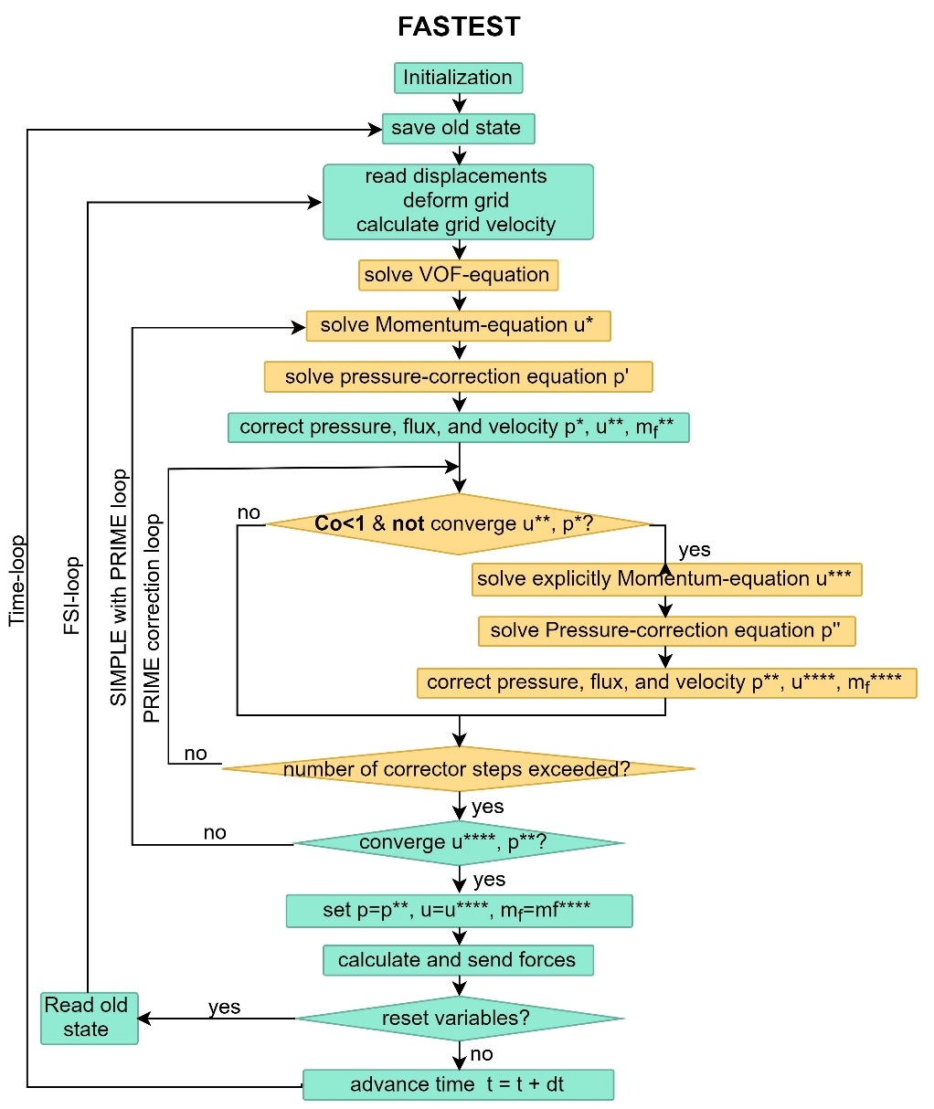

The discretization and the segregation solution method are based on the cell centered collocated Rhie-Chow SIMPLE (Rhie, 1985) algorithm with the modifications to account the effects of underrelaxation (Majumdar, 1988), and the body forces (Mencinger, 2012). In addition, some PRIME (Maliska & Raithby, 1983) explicit correctors steps are added to improve the accelerate the convergence.

The FASTEST code solves the incompressible unsteady or steady Navier-Stokes equations. The velocity field is obtained from the momentum conservation equations and the pressure field is extracted from the continuity equation, using the iterative pressure-corrector algorithm SIMPLE and the Rhie-Chow interpolation for collocated grids. The discrete system is solved via the incomplete LU decomposition method of Stone (1973).

**PRESSURE GRADIENT**

In continuous flow, the free surface appears as a density discontinuity.

The main trouble when solving two-phase flow with large density variations (e.g. air and water) in the same continuum is to obtain a perfect equilibrium between the pressure gradient and the gravity term to prevent the growth of parasitic currents due to gravity, even when surface tension is neglected (Wackers et al., 2011).

The pressure gradient has a jump at the free surface and the density gradient is undefined for a sharp interface. Numerical smearing at the interface avoids the jump behavior. For cells containing the lighter fluid the error is especially large. For density ratios typical for water and air the values could be around 500 times larger. These wrong values lead to unphysical high velocities in the free surface cells containing the lighter fluid (Meyer et al., 2016). Some methods can be used to avoid this problem. For example the method for the reconstruction of the pressure and its gradient at the cell face for arbitrary unstructured grids given in (Queutey & Visonneau, 2007).

Besides, the method of Queutey et al. (Queutey & Visonneau, 2007) was used to reconstruct the pressure discontinuities at the interface, and a new robust rigid body motion method was implemented.

**The discretization of the volume fraction transport equation**

The volume integral of the volume fraction transport equation is solved with the BDF2 time scheme, and the surface integral is numerically approximated by the mid-point ruler. For an arbitrary control volume P, Eq. (5) becomes



where the superscripts *n+1*, *n*, and *n-1* represented the values at the next, current, and last time-step respectively. The subscript *f* denotes the variable approximated at the center of each face of the control volume *P*, and *C* is the convective flux. After some arithmetic operation, the algebraic form of the discretized equation reads



with  and .

*AP* and *AF*are defined according to the advection scheme used to approximate the face volume fraction.

The volume fraction α, which represents the presence (α=1) and the absence (α=0) of the tracked fluid. Values of α between zero and one means a mixture and α=0.5 defines the interface.

The volume of fluid transport equation is strongly dependent on the Courant number according to (Hoekstra et al., 2007). For example, the new volume fraction in a fixed domain using the implicit Euler scheme is obtained as:

$$\begin{matrix}α^{n+1}=α^{n}-\sum_{f}{α_{f}^{n+1}\frac{{\left(uS\right)}_{f}∆t}{δV}} . & (15)\end{matrix}$$

The last part of the Eq. (15) represents the local Courant number on the face.

In the case of moving grids, one has

$$\begin{matrix}α^{n+1}=\frac{{δV}^{n}}{{δV}^{n+1}}α^{n}-\sum_{f}{α_{f}^{n+1}\frac{{{\left(u-v_{g}\right)}_{f}S}_{f}∆t}{{δV}^{n+1}}} , & (16)\end{matrix}$$

the Courant number also depends on the movement of the grid.

Therefore, choosing a consistent high-resolution scheme that can manage this frequent Co changes is an essential part of this investigation.

We found that M-CICSAM keeps the sharpness of the interface until Co=0.5 and is stable using very small time-steps. However, in FSI simulations one often has to work with Co larger than 1 and the coupling itself already consumes a lot of time. Consequently, we need a High-Resolution scheme that allows a Co larger than 1 without losing stability.

**Discretization of the volume of fraction transport equation**

The volume of fraction transport equation Eq. (3.9) is discretized in the space whit FVM and in the time using the Crank-Nicolson method, as is suggested by Ubbink and Issa (O. Ubbink & Issa, 1999). Furthermore, one assumes that influence of the velocity variation during a one-time step is negligible to calculate the volume-fraction so only the previous velocity is used,



The fluxes through faces are grouped into the variable .

To avoid artificial numerical diffusion also known as smearing of the interface, the transport equation has to be solved without excessive diffusion. Thus, the success of a VOF method depends heavily on the used scheme for the advection of the field,  (Darwish & Moukalled, 2006). The estimation of  should be performed with geometric or algebraic schemes instead of a low-resolution scheme as UDS or CDS which produces unboundedness solutions (i.e.  or ) and smears the interface (Mencinger & Žun, 2011). On the one hand, geometric schemes reconstruct accurately the interface within each cell by unions of rectangles, triangles, or regions bounded by piecewise-polynomial surfaces; SLIC (Noh & Woodward, 1976), PLIC (Youngs, 1982), and cubic splines (López, Pereiras, Castro, & Iglesias, 2014) techniques respectively. Even so, they considerably increase the computational effort (Zaleski, 1996). On the other hand, algebraic refers to the schemes typically composed of two standard schemes: one bounded and one anti-diffusive. Although the smearing of the interface can occur, their implementation is considerably simpler, especially on irregular or three-dimensional grids. In the case of FASTEST, it works with algebraic methods which are briefly explained below.

The algebraic schemes are based on the boundedness criterion (CBC) that is illustrated in a Normalized Variable Diagram (NVD). This diagram controls that the different schemes are bounded and preserve the continuous distribution of the variables. The boundedness criterion states that the variable interpolated on the face must be within the range  where  and correspond to the variables in the centers of neighboring control volumes Donor and Acceptor respectively like is shown in Fig. 3.6

Boundedness criterion, the upwind (U), the donor (D), and the acceptor (A) cells

Applying the CBC and using the value of the variable in the upwind control volume , the normalized variables are formulated,





and the range for the new normalized variables is redefined as 

The normalized variables are used to calculate the coefficient  which allows approximating the volume-fraction in the face ,





Nevertheless, in the above equation,  is also unknown, and different techniques have been developed to find this value. The first was the donor-acceptor scheme DAS (Hirt & Nichols, 1981). DAS states that the amount of the transported fluid through the face  of the cell  during one-time step cannot be larger than the amount of the fluid inside the cell. So  where  is the Courant number. However, can be out of the range between zero and one, which results in an unboundedness solution. To overcome this problem DAS was later combined with the upwind scheme because it unconditionally satisfies CBC and thus the Hyper-C scheme appeared \cite{muzaferija1998two}. This last has problems when the interface is tangential to the flow direction and tends to deform it artificially. This inconvenience leads the development of a scheme that considers the geometry of the interface and its relationship with the center of donor and acceptor control volumes. This resulted in CICSAM, which is also called Ultimate-Quickest (UQ) scheme that is obtained from Lagrange interpolation polynomial, see Ref. (Ferziger & Peric, 2012). CICSAM calculates  in function of an angle  between the unit vector normal to the interface and the unit vector parallel to the line between centers of the donor D and acceptor A volumes, see Fig. 3.7.

Fig 3.7 Vector normal to the interface  and vector parallel to the line between centers of D and A control volumes 

Furthermore, CICSAM scheme preserves accurately the shape but when the Courant number becomes larger, numerical diffusion appears. Until here, all the schemes have an explicit dependence on the local Courant number which limits their application. To overpass the issue, the HRIC dynamic scheme was introduced, it does not use in its formulation but can cause stability problems.

Finally, Waclawczyk (Wacławczyk et al., 2007) combined the advantages of the two previous schemes in order to obtain the M-CICSAM scheme which does not depend on the Courant number and avoids the artificial deformation employing a second order accurate bounded linear Fromm scheme (van der Pijl et al., 2005). Using these two constrains M-CICSAM determines the normalized variable  with the following equation,



where,





and  is a blending factor that depends on the orientation of the interface, which is calculated as



At the moment, M-CICSAM is the scheme frequently used in the FASTEST despite the sharpness of the interface to higher Courant numbers is not enough accurate.

**Blended High-resolution (HR) schemes**

The accuracy of the numerical solution of Eq. (7) depends on the proper estimation of the face volume fraction. This demands an advection scheme that should neither produce numerical diffusion nor unbounded values (Muzaferija & Perić, 1999). Over the last decades, blended advection schemes between a compressive and a diffusive high-resolution (HR) scheme have been used to advect the volume fraction. The reason for this is, that the use of just the compressive schemes can cause an alignment of the fluid interface with the grid (Onno Ubbink, 1997), as well as, when the interface is aligned with the flow direction, too much compression of the interface causes spurious oscillations in the interface shape (Wackers et al., 2011). Whereas, the use of just the diffusive HR schemes deteriorates the accuracy when the flow is not orientated along a grid line due to the false diffusion (Fadl Moukalled, Mangani, & Darwish, 2016). The switching strategy depends on the angle *θf* between the flow direction and the grid lines. This approach has been employed to develop several blending advection schemes, also known as interface-capture schemes, for example, CICSAM (O. Ubbink & Issa, 1999), HRIC (Muzaferija & Perić, 1999), STACS (Darwish & Moukalled, 2006), and FBICS (Tsui et al., 2009).

A high-resolution scheme is a composite high-order scheme combined with the Convective Boundedness Criterion (CBC) (Gaskell & Lau, 1988) to ensures that the interpolation profile at the cell face does not underflow or overflow the cell (F. H. Moukalled, Mangani, & Darwish, 2016). Some examples of them are SUPERBEE, MUSCL, SMART or STOIC. The HR schemes can be formulated in the framework of the Normalized Variable Diagram (NVD) (Leonard, 1991) in which the face value is a function of the upwind (U), central (C), and downwind (D) cell that are defined depending on the flow direction (see Fig. 2).

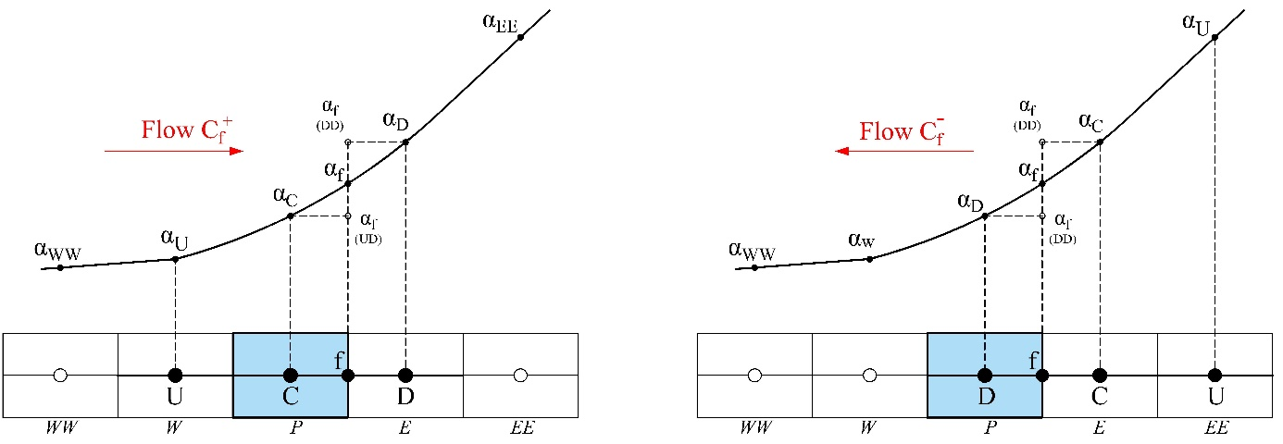

**Figure 2** Schematic position of the nodes D, A, and U according to the direction of the flow and the variation of α in a physical one-dimensional domain.

Fig. 1 illustrates the NVD. UD line refers to the upwind differencing scheme, DD to the downwind differencing scheme, and the shaded area indicates the part of the NVD that fulfils the CBC. The schemes close to the UD line are linked with numerical diffusion but always produce a bounded solution and are stable. Whereas, the schemes near the DD line are unstable but introduce a negative numerical diffusion, so they are known as compressive schemes. Practical schemes are usually designed as bleeds of these elementary schemes.

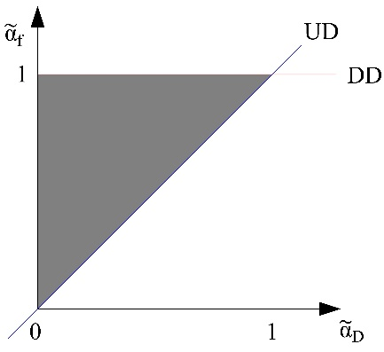

**Figure 3** The NVD combined with the CBC showing the region where is bounded**.**

For the NVD, a normalized volume fraction  is defined as



With this normalization relation 1, , and the normalized volume fraction at the cell face becomes a function of .

Then, a blended HR scheme designed within the NVD framework defines the normalized face volume fraction as



where the blending function *λ = f(θf)* varies between 0 and 1.

Due to its composite nature  cannot be directly expressed in terms of the nodal values of the control volume P and neighbors F, which is necessary to determine the AP and AF coefficients and to solve Eq. (7) for the unknown values at the central nodes. So, the next section explains in detail the proposed new methodology.

**CUIBS scheme**

To keep a sharp water surface, the scheme should ideally be compressive. However, because the solution is discontinuous, boundedness is of the highest importance as well. Another requirement is that the schemes should be work with high Courant numbers Co, to allow the use of reasonable time steps.

* 1. **TEMA 2**

In this paper, we modify the algorithm described above and look for ways to improve its efficiency and to make a consistent coupling with the FSI approach of Schäfer et al. (2006). Firstly, we examine the following two research questions:

1. Should the volume fraction equation be updated once for each internal SIMPLE iteration or once for each time step as suggested in (Sauer, 2000; O. Ubbink & Issa, 1999; D. Zhang et al., 2014) and by other authors?
2. Does the use of a constant density in the time discretization, as in the original multiphase implementation in FASTEST (Staab, 2016; Wacławczyk, 2007), affect the accuracy of the results?

Gillebaart et al. (2016) stated that an important factor to achieve a consistent fluid-structure interaction simulation is the time integration scheme used in the structure and fluid solvers. The most straightforward approach is using the same time discretization scheme for both the fluid and the structure to ease the coupling of forces and displacement. For the fluid domain, they found that the computation time of the second order Backward Differentiation (BDF2) is lower than Euler implicit for the same accuracy. Similarly, Flitz, Sternel, and Schäfer (2011) demonstrated that the accuracy of the fluid-structure interaction with single-phase fluids is higher, using BDF2 than using Implicit Euler, and BDF2 also allows the use of larger time steps.

First, the above four research questions are investigated for the multiphase case. The benchmark case “rising bubble” presented in (Hysing et al., 2009) is used to verify the new implementations in the multiphase code. The parameters of interest with respect to the first research question are the computational time and the accuracy of the system. To achieve the third objective, three high-resolution schemes are implemented: HRIC (Muzaferija & Perić, 1999), M-HRIC (Park et al., 2009), and STACS (Darwish & Moukalled, 2006) which are known for being less dependent on the Courant number. The second and fourth research interests are analyzed together. Two alternatives to include the variation of the density in time are proposed, which consider the conservative and nonconservative form to discretize the time term.

We use the Parker and Youngs´ algorithm (Pilliod & Puckett, 2004) to calculate the surface tension.

A simplified version of the momentum and volume of fluid transport equation can be written as:

$$\begin{matrix}\frac{∂(ρuδV)}{∂t}+L\left(u\right)=0 , & (9) \\ \frac{∂(αδV)}{∂t}+G\left(α\right)=0 , & (10)\end{matrix}$$

where the functions L and G contains the terms of the space discretization. For the time discretization, the implicit Euler, the second order backward differentiation BDF2, and the Crank Nicolson method are tested. For the momentum equation the following options are proposed:

1. conservative discretization of $uδV$ and constant density, proposed in (Wacławczyk, 2007)
2. conservative discretization: $ρuδV$ is treated as one term.
3. nonconservative discretization: $ρ$ and $uδV$ are treated as two distinct terms (only for multiphase problems)
4. nonconservative discretization: $ρu$ and $δV$ are treated as two distinct terms.

The next section presents the discretization time term of the momentum equation applying the four concepts.

For Implicit Euler and Crank Nicolson:

$$\begin{matrix}\frac{ρ}{∆t}\left[{(uδV)}^{n+1}-{(uδV)}^{n}\right] , & (11.A) \\ \frac{1}{∆t}\left[{(ρuδV)}^{n+1}-(ρ{uδV)}^{n}\right] , & (11.B)\end{matrix}$$

$$\begin{matrix}\frac{ρ^{n+1}}{∆t}\left[{\left(uδV\right)}^{n+1}-{\left(uδV\right)}^{n}\right]+\frac{{(uδV)}^{n+1}}{∆t}\left[ρ^{n+1}-ρ^{n}\right], & \left(11.C\right)\end{matrix}$$

$$\begin{matrix}\frac{{(ρu)}^{n+1}}{∆t}\left[{δV}^{n+1}-{δV}^{n}\right]+\frac{{δV}^{n+1}}{∆t}\left[{(ρu)}^{n+1}-{(ρu)}^{n}\right], & (11.D)\end{matrix}$$

and for the second order backward differentiation (BDF2):

$$\begin{matrix}\frac{ρ}{∆t}\left[{\frac{3}{2}(uδV)}^{n+1}-2{\left(uδV\right)}^{n}+\frac{1}{2}{\left(uδV\right)}^{n-1}\right], & (12.A)\end{matrix}$$

$$\begin{matrix}\frac{1}{∆t}\left[{\frac{3}{2}(ρuδV)}^{n+1}-2{\left(ρuδV\right)}^{n}+\frac{1}{2}{\left(ρuδV\right)}^{n-1}\right], & (12.B)\end{matrix}$$

$$\begin{matrix}\frac{ρ^{n+1}}{∆t}\left[{\frac{3}{2}(uδV)}^{n+1}-2{\left(uδV\right)}^{n}+\frac{1}{2}{\left(uδV\right)}^{n-1}\right]+ \\ \begin{matrix}\frac{{(uδV)}^{n+1}}{∆t}\left[{\frac{3}{2}ρ}^{n+1}-2ρ^{n}+\frac{1}{2}ρ^{n-1}\right], & (12.C)\end{matrix}\end{matrix}$$

$$\begin{matrix}\frac{{(ρu)}^{n+1}}{∆t}\left[{\frac{3}{2}δV}^{n+1}-2{δV}^{n}+\frac{1}{2}{δV}^{n-1}\right]+ \\ \begin{matrix}\frac{{δV}^{n+1}}{∆t}\left[{\frac{3}{2}(ρu)}^{n+1}-2{(ρu)}^{n}+\frac{1}{2}{(ρu)}^{n-1}\right]. & (12.D)\end{matrix}\end{matrix}$$

For the VOF equation, the options A and B are the same, using the conservative form, and the options C and D are also the same, using the nonconservative form.

For Implicit Euler and Crank Nicolson (CR-NI):

$$\begin{matrix}\frac{1}{∆t}\left[{αδV)}^{n+1}-({αδV)}^{n}\right] , & (13.A) \\ \frac{α^{n+1}}{∆t}\left[{δV}^{n+1}-{δV}^{n}\right]+\frac{{δV}^{n+1}}{∆t}\left[α^{n+1}-α^{n}\right] , & (13.C)\end{matrix}$$

and for BDF2

$$\begin{matrix}\frac{1}{∆t}\left[{\frac{3}{2}(αδV)}^{n+1}-2{\left(αδV\right)}^{n}+\frac{1}{2}{\left(αδV\right)}^{n-1}\right] , & (14.A)\end{matrix}$$

$$\begin{matrix}\frac{α^{n+1}}{∆t}\left[{\frac{3}{2}δV}^{n+1}-2{δV}^{n}+\frac{1}{2}{δV}^{n-1}\right]+ \\ \begin{matrix} \frac{{δV}^{n+1}}{∆t}\left[{\frac{3}{2}α}^{n+1}-2α^{n}+\frac{1}{2}α^{n-1}\right] . & (14.C)\end{matrix}\end{matrix}$$

For the case of fixed grids, the volume $δV$ is a constant in the discretization.

**Rising bubble**

This is an example of bubble dynamics with surface tension effects and strongly discontinuous solutions (Hysing et al., 2009) and is commonly used as a benchmark to test multiphase codes. A bubble of diameter 0.5 m centered (0.5 m, 0.5 m) in a tank of width 1 m and height 2 m. No-slip boundary conditions are applied to the top and bottom boundaries, whereas a symmetry condition is imposed on the vertical walls. The geometric configuration is presented in Fig. 3 and the physical parameters of the fluids are listed in Table 1. The selected physical quantities to compare our results are the position of the center of mass and its mean rising velocity defined as:

$$\begin{matrix}y_{c}=\frac{\sum_{{i∈Ω}_{2}}{y_{i}{δV}_{i}}}{\sum_{{i∈Ω}_{2}}{{δV}_{i}}}, & v_{c}=\frac{\sum_{{i∈Ω}_{2}}{v_{i}{δV}_{i}}}{\sum_{{i∈Ω}_{2}}{{δV}_{i}}} . & (17)\end{matrix}$$

These quantities not only measure how the interface tracking algorithm behaves but also indicate the quality of the overall solution.

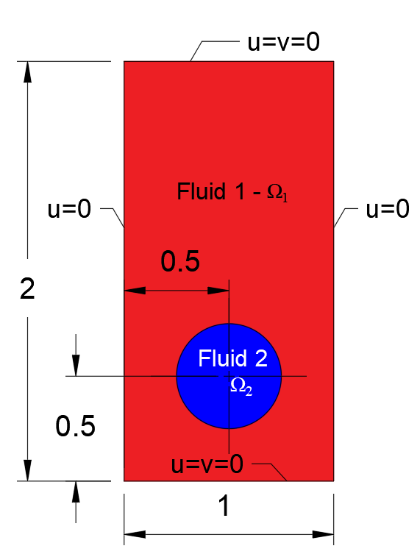

**Figure 3:** Initial configuration and boundary conditions for the rising bubble problem.

**Table 1.** Physical properties of the fluids and dimensionless numbers for the rising bubble test case.

|  |  |  |  |  |  |  |  |
| --- | --- | --- | --- | --- | --- | --- | --- |
| ρ1 | μ1 | ρ2 | μ2 | g | σ | Re | E0 |
| 1000 | 10 | 1 | 0.1 | 0.98 | 1.96 | 35 | 125 |

For all cases analyzed, the computations were conducted until the time t = 3 s with a constant time-step Δt = 0.0025 s. The solver worked in parallel using 16 processors. The computational domain was a structured grid of 160x320 hexahedral control volumes. To reproduce the 2D solution, in the z-direction, only one control volume is considered with periodic boundary conditions. The required convergence criterion is 10-4 for the momentum equation and the limit of iterations per time step is 250.

36 simulations of the rising bubble test case are made to compare the efficiency and limitations of the High-resolution schemes: M-CICSAM, HRIC, M-HRIC, and STACS in combination with the time integration schemes: Implicit Euler, BDF2, and Crank Nicolson (CR-NI). For the momentum and the volume of fluid transport equations the same time discretization scheme is used. This part also includes the analysis of the discretization form A, B and C described in the previous section. Option A was calculated in every SIMPLE iteration, and option B and C in every time step. The results of these cases are summarized in Figs. 4 - 6, and Table 2.

Figure 4 shows the comparison of the different methods for the center of mass and the rise velocity for the rising bubble problem. For BDF2 and Implicit Euler, all the high-resolution schemes with option A perfectly coincide with the









**Figure 4**: Center of mass and rise velocity of the rising bubble during 3s. The reference refers to the results of Hysing et al. (2009).

reference. It is important to mention that the results presented in (Hysing et al., 2009) were also obtained, considering a constant density in the time term and an update of VOF for each internal iteration. Figure 6 shows the evolution of the interface in time which is similar to the references results.

Moreover, option B and C are very similar to each other but are different from the reference results. The difference indicates that the frequency of VOF updates and the consideration of the density in the time term affects directly the complete solution of the system. Nevertheless, the discretization form of the time term, conservative or nonconservative, does almost not present significant differences. The center of mass at 3 s for the options B and C was around 4 % lower than for option A. The final mean rise velocity is between 0.21m/s to 0.25m/s for these cases.

Notable differences are observed in the maximum mean velocity, for which evolution with time seems to depend significantly on the time discretization scheme. For BDF2 and Implicit Euler with option A, the maximum velocity is around 0.25 m/s at 0.79 s and after this point, the velocity remains almost constant. Whereas with option B and C the maximum velocity is 0.35 m/s at 1.0 s and then the velocity gradually decreases until 0.21 m/s. On the other hand, the results with Crank-Nicolson are significantly different from the other schemes. For option A, the center of mass is 6% above the reference and the rise velocity follows the tendency of the reference but is slightly higher. While option B and C present unrealistic peaks, which destabilize the VOF equation.



Figure 5: Cumulative number of iterations and absolute error of the moment equation by time-step.

Since the options B and C are not enough accurate, we performed an extra analysis to determine the accuracy and precision of the algorithm, taking into account that in option A the VOF equation is updated once for each internal SIMPLE iteration and for the options B and C, the update is done for each time step. For this part, we use the implemented BDF2 method in combination with the M-CICSAM scheme and compare the total number of iterations,

Table 2. Summary of the maximum Courant number and the total number of iterations for each High-Resolution scheme in combination with the different time discretization options.

|  |  |  |  |  |  |  |  |  |  |  |  |  |
| --- | --- | --- | --- | --- | --- | --- | --- | --- | --- | --- | --- | --- |
| **HR scheme** | **M-CICSAM** | | | **HRIC** | | | **M-HRIC** | | | **STACS** | | |
| **Option** | **A** | **B** | **C** | **A** | **B** | **C** | **A** | **B** | **C** | **A** | **B** | **C** |
| **BDF2** | | | | | | | | | | | | |
| max. Co | 0.35 | 0.44 | 2.25 | 0.34 | 0.45 | 0.45 | 0.34 | 0.44 | 0.45 | 0.33 | 0.44 | 0.45 |
| time(maxCo) | 2.05 | 1.67 | 0.85 | 2.11 | 1.66 | 1.66 | 2.10 | 1.66 | 1.64 | 2.04 | 1.65 | 1.65 |
| Iterations | 122959 | 73657 | 68537 | 112321 | 73191 | 68033 | 118463 | 73217 | 68144 | 111163 | 67531 | 67652 |
| **Crank – Nicolson** | | | | | | | | | | | | |
| max. Co | 0.47 | 6.03 | 2.25 | 0.45 | 1.65 | 2.09 | 0.45 | 2.66 | 2.74 | 0.43 | 4.65 | 2.53 |
| time (maxCo) | 1.72 | 0.90 | 0.85 | 1.71 | 0.99 | 0.97 | 1.69 | 0.98 | 0.88 | 1.68 | 0.97 | 0.79 |
| Iterations | 223832 | 67390 |  | 200478 | 107315 | 106801 | 203984 |  |  | 299998 |  |  |
| **Implicit Euler** | | | | | | | | | | | | |
| **max. Co** | 0.35 | 0.44 | 0.45 | 0.34 | 0.45 | 0.47 | 0.34 | 0.44 | 0.45 | 0.33 | 0.45 | 0.46 |
| **time(maxCo)** | 2.04 | 1.67 | 1.66 | 2.08 | 1.67 | 1.66 | 2.10 | 1.66 | 1.64 | 2.06 | 1.66 | 1.65 |
| **Iterations** | 178761 | 92129 | 92266 | 173534 | 126594 | 91670 | 112746 | 91791 | 91747 | 172596 | 91487 | 91486 |

Note: The gray color means that simulations diverged



1. t = 6s b) t=1.8s c) t=2.4s t=3.0 s

**Figure 6**: Time evolution of the interface and velocity in the y-direction for the MHRIC scheme combined with BDF2.

the evolution of the error, and the maximum local Courant number for options A and B, see Fig. 5. The total number of iterations for option A (one VOF update for each iteration) is around 40% more than with option B (one VOF update for each time-step). This means that the actual computational time is lower with the same proportion for option A. On the other hand, the two options meet the convergence criterion most of the time.

We notice that the two options need the same number of iterations to converge if the local Courant number is less than 0.2. For Co larger than 0.3, the solver becomes noticeably imprecise for option A and needs to perform more iterations to achieve the required precision. The reason could be the continuous oscillations introduced in the solution by the diffusive schemes such as M-CICSAM. The oscillation varies depending on the velocity profile, Co number and time according to Arıcı and Sinasi Onur (2011). Although option B has no problems with precision it is evident that for Co larger than 0.2, the results become inaccurate due to the calculation of the DWF factors in the volume of fluid equation with the old volume fractions. Ubbink and Issa (1999) recommended working with values less than 0.3 to maintain accuracy in the case of CICSAM. We determine that this condition applies for any HR scheme that is implemented with the Downwind Weighting Factors (DWF) method.

On the other hand, the four high-resolution schemes are stable with BDF2 and Implicit Euler time discretization. Instead, with Crank Nicolson, only HRIC is stable for the 3 options. For all the cases, BDF2 and Implicit Euler are faster than Crank-Nicolson, almost 40% and 16%, respectively. For BDF2, the STACS scheme with option B needs the least iterations to achieve the solution of the problem. For Crank-Nicolson, only considering the stable option A, M-HRIC is the fastest scheme, while for implicit Euler it is the M-HRIC scheme with option C. In general, for BDF2 and Implicit Euler, the option C is the less computing time. Table 2 summarizes the total number of iterations performed by each combination as well as the maximum local Courant number. In the case of BDF and Implicit Euler the maximum Courant number is around 0.35 at 2.11 s for option A, and for options B and C, it is around 0.45 at 1.66 s. In the case of Crank Nicolson: The maximum Courant number for option A is 0.49 at 1.80 s. The results show that Crank Nicolson is only stable when the difference of the density is not considered. For options B and C, M-CICSAM, STACS, and M-HRIC diverged. For Crank Nicolson, the instabilities of the velocity induce high Courant numbers which are causing a break of the simulation.

1. **Conclusions**

We successfully modified the standard algorithm to solve multiphase flow problems in order to use moving grids in the in-house solver FASTEST. The main part of our investigation was focused on the comparison of four high-resolution schemes in combination with different time discretization methods and the effects of the density changes. With respect to the first research question, we conclude that the most efficient option is to update the VOF once for each time step which decreases the computational time by around 40%. Also, smaller time-steps should be used in order to maintain accuracy.

The use of a constant density in the time discretization is appropriate only if the volume fraction update is performed for every internal iteration. In contrast, if the volume fraction is updated in every time-step, the variation of the density in time should be considered to obtain accurate results.

BDF2 and Implicit Euler were faster than the Crank-Nicolson time discretization method, by almost 40% and 16% respectively. BDF2 and Implicit Euler are consistent when used in multiphase flows, whereas Crank Nicolson was inconsistent for the options B and C, which consider the changes of density and update the VOF equation only once for every time-step.

The difference between the conservative and nonconservative form to discretize the time term was negligible. For some cases, the nonconservative method was a little faster.

The four high-resolution schemes presented good results to simulate multiphase flows, but they were inconsistent when used with moving grids. Additional work is needed to find better options for HR-schemes and methods to implement them.

**A *Modified Normalized Weighting Factor method for improving the efficiency of the blended high-resolution advection schemes in the context of multiphase flows***

**Abstract:** This work deals with a new methodology for the implementation of high-resolution (HR) schemes employed to advect the volume fraction in the Volume of Fluid (VOF) method, in which the numerical stability and convergence depend heavily on the numerical advection scheme and implementatin method. The proposed method is based on the normalized weighting factor (NWF) method, which linearizes the normalized interpolation profile and rewrites the face value directly using the donor, acceptor, and upwind nodes. However, unlike the NWF, which is fully implicit and results in pentadiagonal linear systems, the new modified normalized weighting factor method (MNWF) only forms the implicit terms with the contribution of the donor and acceptor nodes, while the contribution of the upwind node explicitly forms part of the source term. Therefore, the method results in a tridiagonal linear system. The comparison of the new method with the deferred correction (DC), downwind weighting factor (DWF), and the RNWF methods shows that the MNWF requires about 5-25% fewer iterations than DC and RNWF, and around 10-85% less than DWF. Thus, a similar order of accuracy of the results can be obtained with less computational time.

* **Introduction**

The volume of fluid method (VOF) of (Hirt & Nichols, 1981) is a well-established conservative method to solve multiphase flow problems. The VOF introduces an additional transport equation to advent a marker function called volume fraction to define the position of the interface between the fluids. The volume fraction must be updated every time that the fluids move, and the boundary between the different fluids changes position. Nevertheless, updating the marker function is critical for the success of the simulation of multiphase flows and also is not a trivial job due to the purely convective nature of the transport equation (Tryggvason et al., 2001).

An option to deal with this problem is using the blended High-Resolution (HR) schemes also known as interface-capture schemes which combine a high order (HO) diffusive scheme, a compressive scheme, and the Convection Boundedness Criterion (CBC) ensuring that no oscillatory behavior is experienced in the solution and have relatively low numerical diffusion (F Moukalled, Mangani, & Darwish, 2016; Tryggvason et al., 2001). An example of such schemes is CICSAM (O. Ubbink & Issa, 1999). However, the direct introduction of the blended HR schemes into the discretized equation is not suitable because of their composite nature. Thus, some techniques initially created to implement the HR-schemes in the momentum equation have been used to overcome this difficulty.

For instance, (Meyer et al., 2016) implemented the blended interface capture scheme BICS (Wackers et al., 2011) with the deferred correction (DC) method of (Rubin & Khosla, 1977) to develop a new code for simulating free-surface flows around modern sailing yachts. For the DC method, the implicit terms of the discretized equation are based on the upwind scheme, whereas the difference between the BICS schemes and the upwind scheme is considered as a source term. Although according to (Darwish & Moukalled, 1996), DC suffer from low convergence rates, whereas the general approach of Meyer et al. showed better performance than other codes. However, the influence of DC on the general approach was not studied.

On the other hand, CICSAM and its modifications such as THOR (Hogg, Gu, & Emerson, 2006), MCICSAM-W (Wacławczyk et al., 2007), and MCICSAM-Z (C. Zhang, Lin, Tang, & Zhao, 2014) employ the Downwind Factor Method (DWF) method of (Leonard & Mokhtari, 1990). The DWF introduces an auxiliary factor that implicitly contains higher-order wide-stencil information, but its implementation involves only the adjacent upwind and downwind node values. So, this method is suitable for tridiagonal solvers. However, the coefficients obtained from a DWF implementation sometimes are not diagonally dominant; thus, the formulation is not stable for many flow configurations and requires substantial relaxation to achieve convergence. Despite the described problem, this method is still used commonly in the multiphase community.

Another technique that overcomes the shortcomings of the DWF method, but which is rarely applied in the context of multiphase flows is the full implicit Normalized Weighing Factor (NWF) method(Darwish & Moukalled, 1996). The NWF linearizes the normalized interpolation profiles and rewrites the face value directly using the central, upwind, and downwind nodes so that the method uses a pentadiagonal stencil, and the diagonal coefficient results always positive. Consequently, the NWF is much more robust than the DWF and faster than DC methods (Darwish & Moukalled, 1996). Nevertheless, NWF is not frequently used because it requires the pentadiagonal matrix algorithm (PDMA) to solve the system of equations.

In 2018, a revision of the described normalized weighting factor (RNWF) method was presented by Chourushi, which is applicable for tridiagonal equation solvers. This method relies on the final discretization of the normalized weighting factor method and removes the contribution of far-off nodal values from the diagonal coefficient. These terms are later added as a source term. According to the author, the RNWF is four times faster than DC and 1.3 times faster than NWF.

Because of the stability advantages and efficiency of the NWF formulation compared to DC and DWF, and the new possibility of using it with tridiagonal equation solvers, we tested the RNWF method in the context of multiphase fluids and found that the convergence rate of the RNWF is similar to the DC method in the case of multiphase flows and that the RNWF method tends to degenerate the interface slightly. We supposed that the problem lies in the introduction of two explicit terms in the source term, the value of the center point and the upwind point instead of only the upwind point as is suggested in the original NWF method. Our new idea is only to introduce the upwind value as a source term.

This paper presents this new idea that we call Modified Normalized Weighting Factor (MNWF) method which we apply for the numerical implementation of six blended HR schemes: CICSAM, MCICSAM-W, MCICSAM-Z, HRIC (Muzaferija & Perić, 1999), FBICS (Tsui et al., 2009), and CUIBS (Patel & Natarajan, 2015). The implementations are realized on the in-house finite-volume flow solver FASTEST, based on a block-structured collocated grid arrangement. For the investigation, we consider four test cases: the slotted circle, the circle in shear fluid, the rising bubble, and the break-dam with an obstacle. The convergence rate is given by the total number of iterations required for convergence, and the accuracy of the results is analyzed for each test cases and compared with one the obtained using the DC, DWF, and RNWF methods.

* **Mayor implementation methods for HR schemes**
  1. **Deferred corrector approach**

The deferred corrector (DC) method of Rubin & Khosla (1977) is a simple technique designed for tridiagonal matrix solvers that define the convective term of the volume fraction equation as

 (10)

The first term, the value obtained by the upwind scheme, is used to form the coefficients matrix A for the nodal algebraic equation, while the second term, the difference between the blended HR and UD schemes is explicitly computed using the last available values and added to the source term. Thus, the resulting coefficient matrix is always diagonally dominant, yielding a numerically stable method. Nevertheless, the convergence rate decreases as the difference between the cell face value estimated by the upwind scheme and the blended HR scheme increases (F Moukalled et al., 2016).

* 1. **Downwind Weighting Factor method**

The Downwind Weighing Factor (DWF) method was developed by (Leonard & Mokhtari, 1990) to overcome the low convergence rate associated with the DC method. The face value is defined as a weighted average between the donor and acceptor cell written as

 (11)

where the *DWF* is the weighting factor that varies between 0 and 1 and is explicitly computed as

 (12)

Then, the convective term using nodal values and considering the flow direction takes the form

 (13)

which is used to generate the coefficients matrix A.

The effect of this weighting formulation is a reduced stencil for the discretized coefficients, which allows the system of equations to be solved with a tridiagonal solver. However, the diagonal coefficient Ap becomes negative when which is a common scenario for all HR schemes when . Consequently, this system of equations leads to unphysical results for many flow configurations and requires substantial relaxation to avoid convergence problems (Darwish & Moukalled, 1996).

* 1. **Normalized Weighting Factor method**

The Normalized Weighting Factor (NWF) method of (Darwish & Moukalled, 1996) describes the normalized face value as a linear function of the normalized donor value write as

 (14)

where  represents the slope and *m* the intercept of each linear function that is part of the HR scheme employed. Then, this linear relation is rewritten as

 (15)

yielding

 (16)

The convective term using the nodal values is

 (17)

The last expression allows the full implicit treatment of the HR schemes, so the values of the far nodes  and  are actual nodes in the computational domain that can be resolved in the algebraic equation. For the one-dimensional structured grid, as shown in Fig. 2, the NWF form of the algebraic equation becomes

 (18)

where

 (19)

*AP(time)* and *bP* remain as defined in the last part of section 3.

The above coefficients form a diagonally dominant matrix in which *Ap* is always greater than zero because for almost all HR schemes,  is greater than m. Only for the DD scheme , *Ap* becomes zero. In this case,  is set to  where *L* is the value of from the previous interval of the composite scheme.

The NWF formulation is more robust than the DWF and faster than the DC method (Chourushi, 2018; F Moukalled et al., 2016). However, the discretization above involves a pentagonal stencil that includes the far nodes in each coordinate direction which result in a pentadiagonal coefficient matrix.

* 1. **Reviewed Normalized Weighting Factor (RNWF) method**

The Reviewed Normalized Weighting Factor method developed by (Chourushi, 2018) is a tridiagonal version of the previously described NWF method. From the discrete equation (18), the change from pentadiagonal to tridiagonal stencil was performed considering the far nodes EE and WW as explicit. Then, these nodal values with their AEE and AWW coefficients are placed in the source term. Also, *AEE* and *AWW*are removed from the AP coefficient and added to the source term, resulting in the following modification of the previous Ap and bp terms

 (20)

In addition, to improve the numerical stability, the  factors in the case of the DD scheme are changed to .

The RNWF method was 4 times faster than DC and 1.3 times faster than NWF for the test cases studied in (Chourushi, 2018). However, for our case, the numerical implementation of the interface-capture schemes in the context of multiphase flows, the RNWF did not show the same excellent efficiency than in the cases studied by Chourushi and sometimes slightly altered the interface geometry.

1. **Modified Normalized Weighting Factor (MNWF) method**

Encouraged by the numerical stability and efficiency of the NWF method, we decided to review again its formulation to be used in the context of multiphase flows. Unlike the RNWF, the formulation of our new alternative called Modified Normalized Weighting Factor (MNWF) method starts from the initial formulation of the NWF method and not from its final discretized equation as the RNWF method does.

First, the values of and *m* for the interface-capture scheme are determined according to Eq. (14) and following the blending concept of Eq. (7). The values of and *m*for some popular blended RH-schemes used in the context of multiphase flows are listed in Table 1.

**Table 1**and m factors in the NVD framework for some blended HR-schemes used to advent the volume fraction.

|  |  |
| --- | --- |
| **Blended HR-scheme** | **factors for uniform grids** |
| **CICSAM**  (O. Ubbink & Issa, 1999)    Compressive scheme:  HYPER-C (CBC)  Diffusive HR scheme:  ULTIMATE-QUICKEST (UQ)  Blending function: |  |
| **MCICSAM-W**  (Wacławczyk et al., 2007)    Compressive scheme:  The steady version of HYPER-C (CBC)  Diffusive scheme:  FROMM (FR)  Blending function: |  |
| **MCICSAM-Z**  (D. Zhang et al., 2014)    Compressive scheme:  Compressive differencing scheme (CN-CBC) based on SUPERBEE  Diffusive scheme:  MUSCL  Blending functions:  , , and (for more details, refer to the original paper) |  |
| **HRIC**  (Muzaferija & Perić, 1999)    Compressive scheme:  Bounded downwind (BD)  Diffusive scheme:  The upwind differencing (UD)  Blending function:    Besides, an extra correction considering the value of Co |  |
| **FBICS**  (Tsui et al., 2009)    Compressive scheme:  Bounded downwind (BD)  Diffusive scheme:  A HR scheme (HR)  Blending function: |  |
| **CUIBS**  (Patel & Natarajan, 2015)    Compressive scheme:  Bounded downwind (BD)  Diffusive scheme:  A HR scheme (HR)  Blending function: |  |

Second, to ensure numerical consistency, the *m* factors for the blended HR scheme is corrected with the CBC condition. For which is explicitly calculated using the blended HR scheme, and then bounded as

 (21)

This bounded value is used to corrected m according to

 (22)

Third, when , the strategy introduced in the RNWF methodology is used instead of the original NWF strategy as it proved to be more numerically stable. Thus, the factors are set to  where L is the  factor of an interval of the diffusive HR-scheme to preserve stability.

Fourth, following Eq. (15), Eq. (16) is obtained which is rewritten here for convenience as

 (23)

At this point of the NWF formulation, we decided to use only the terms related to the donor and acceptor nodal values to form the matrix coefficients of *A*, while the last term involving the far node *U* is explicitly determined and added directly to the source term as is shown in (F Moukalled et al., 2016). Hence, the expression in terms of nodal values Eq. (17) is used to obtain the following algebraic equation:

 (24)

where

 (25)

Finally, for a better explanation of the MNWF method, we give the algebraic equation for the one-dimensional structured grid presented in Fig. 2:

 (26)

where



**Results and Discussion**

In this section, four test cases are presented to demonstrate the accuracy and efficiency of the new Modified Normalized Weighting Factor (MNWF) method. The results are compared with the traditional techniques Deferred Corrector (DC), Downwind Weighting Factor (DWF), and the recent alternative the Reviewed Normalized Weighting Factor (RNWF) method. For this purpose, the six blended high-resolution schemes described above (CICSAM, MCICSAM-W, MCICSAM-Z, HRIC, FBICS, and CUIBS) were implemented employing the four techniques. The efficiency is related to the computational effort of each technique; in other words, the total number of iterations required to achieve the convergence criterion during the simulation. The solution is assumed to have converged when the normalized residual defined by Eq. (28) is less than the chosen convergence criterion (*ζ*):

 (28)

For all the cases, no under-relaxation factor is used, and the maximum number of iterations per time step is limited to 20. Whereas the convergence criterion is different for each case.

The solution algorithm employed for all the cases is a sequential one. At each time-step, the volume fraction equation (3) is firstly solved at the beginning of each time-step. Then, the new volume fraction field is used to compute the local density and viscosity using Eq. (4), and finally, the momentum and continuity equations (1-2) are solved by the predictor-corrector SIMPLE algorithm.

The first two test cases are the advection of the slotted circle in a rotational flow field introduced by (Zalesak, 1979) and the advection of a circle in a shear flow presented by (Rudman, 1997) which have simple exact solutions. These are frequently used in the multiphase community to check the performance of the advection schemes dealing with a non-uniform distribution of the Courant number and a considerable interface deformation, respectively (Patel & Natarajan, 2015). For both, the accuracy of the simulation results is verified using the root mean square (RMS) error defined as

 (29)

where  is the numerical solution, is the exact solution, and N is the total number of control volumes. The initialization of the volume fraction field for these cases are illustrated in Fig. 3.

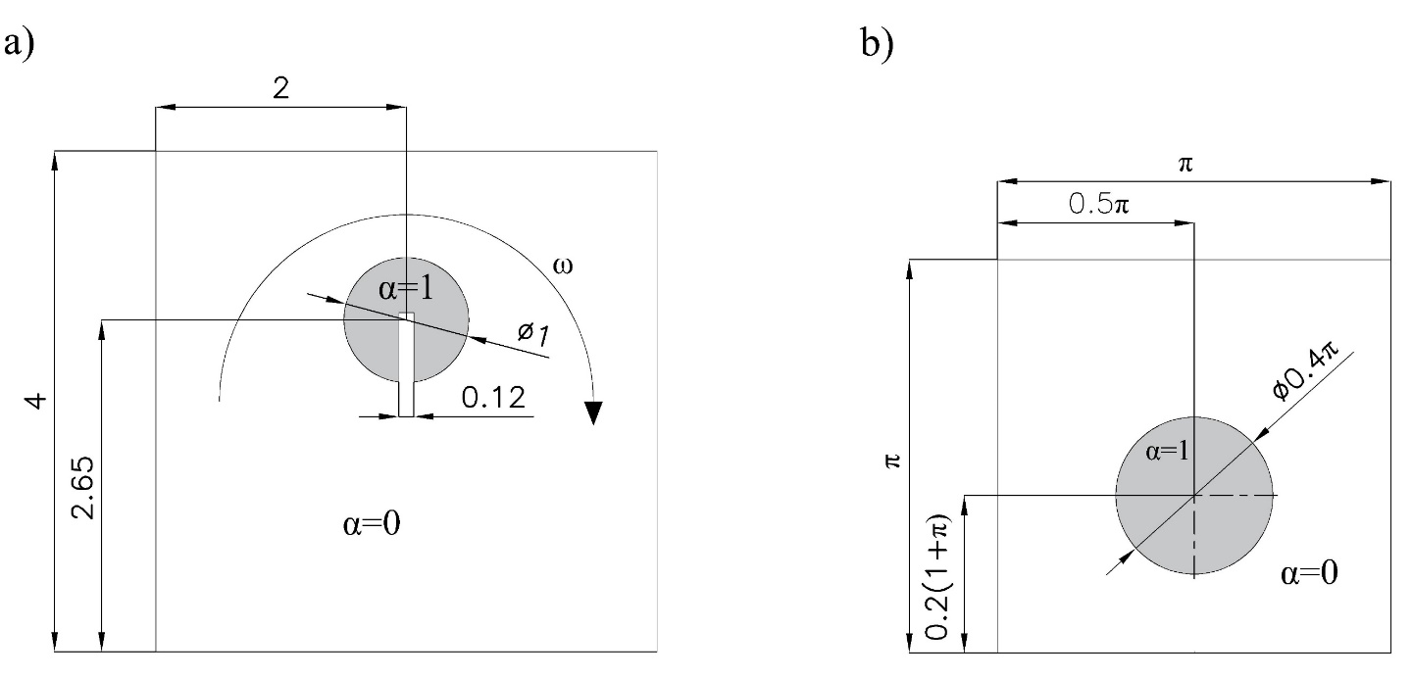

**Fig. 3** Initial configuration for a) the slotted circle test case and b) the circle in a shear flow

**7.1 Advection of a Slotted Circle in a rotational flow**

A circle with a diameter of 1 m and a slot of width 0.12 m and depth 0.62 m is centered at (2, 2.65) m of a square 4x4 m2 domain, and exposed to a clockwise circular velocity given by

 (30)

where (*x0, y0*) = (2, 2) is the center of the rotation and *ω* = 0.5 rad/s is the constant angular velocity. The time needed for one rotation is 12.57 s. The problem is discretized with a structured grid of 200x200 square control volumes, and it is solved for five different time-step sizes which produce a maximum Courant number (Co) of 0.2, 0.4, 0.6, and 0.8 at point (2, 2.15) m (Darwish & Moukalled, 2006). The convergence criterion is *ζ* =5x10-3.

The stacked columns shown in Fig. 4 represent the total number of iterations that each HR-scheme performed to converge during one rotation of the slotted circle at different maximum Courant numbers. The bottom layer of the column represents the number of iterations performed using the DC method, the second relates to the DWF, the third to RNWF, and the last to MNWF. The results for the six different HR schemes are displayed in a) to f), with CICSAM shown in a), MCICSAM-W in b), MCICSAM-Z in c), HRIC in d), FBICS in e), and CUIBS in f). The efficiency between the four methods varies according to the HR scheme. However, for all of them, the new MNWF is the fastest to reach the convergence, whereas the DWF method is the slowest. For example, for CICSAM and MCICSAM-Z, the MNWF is about 20-35% faster than DC and RNWF, and 35-80% faster than DWF. Whereas for the HRIC and MCICSAM-W scheme, the MNWF works similarly to DC and RNWF but is noticeably better than DWF with about 20-85% fewer total iterations. In the cases of FBICS and CUIBS, the total number of iterations used by MNWF is from 12-25% less than by DC and RNWF, while 10-85% less than for DWF.

On the one hand, for low Co, the influence of the implementation method is negligible for all schemes. On the other hand, for medium and high Co, the implementation method plays a significant role. For instance, the MNWF is about 10-30% more efficient than DC and RNWF, and 50-85% than DWF.



**Fig. 4** Comparison of the total number of iterations required for the convergence of a) CICSAM, b) HRIC, c) MHRIC, d) MCICSAM, e) FBICS, and f) CUIBS implemented using the DC, DWF, RNWF, and the new MNWF method at different maximum Courant numbers.

Table 2 shows the accuracy of each HR scheme implemented through the four different techniques. For CICSAM, HRIC, and MCICSAM-W, the error varies according to the implementation technic used, and it is more significant for high Co. Nonetheless, the best performance remains in MNWF. To visualize this difference in accuracy, Fig. 5 shows the contour plots at Co = 0.8 of these three schemes. For the other three HR schemes, the error is independent of the implementation method.

**Table 2** RMS error after one rotation of the slotted circle

|  |  |  |  |  |  |  |  |  |  |  |  |  |
| --- | --- | --- | --- | --- | --- | --- | --- | --- | --- | --- | --- | --- |
| HR scheme | CICSAM [x10-2] | | | | MCICSAM-W [x10-2] | | | | MCICSAM-Z [x10-2] | | | |
| Co | DC | DWF | RNWF | MNWF | DC | DWF | RNWF | MNWF | DC | DWF | RNWF | MNWF |
| 0.2 | 1.55 | 1.63 | 15.50 | 1.54 | 2.64 | 2.41 | 2.54 | 2.78 | 1.21 | 1.21 | 1.21 | 1.21 |
| 0.4 | 1.69 | 1.87 | 7.53 | 1.48 | 2.62 | 2.42 | 2.51 | 2.40 | 1.28 | 1.28 | 1.28 | 1.28 |
| 0.6 | 2.09 | 2.23 | 6.08 | 1.82 | 2.93 | 2.35 | 2.59 | 2.80 | 1.46 | 1.46 | 1.46 | 1.46 |
| 0.8 | 3.36 | 3.38 | 5.35 | 3.25 | 3.00 | 2.88 | 2.90 | 2.44 | 2.10 | 2.10 | 2.10 | 2.10 |
| HR scheme | HRIC [x10-2] | | | | FBICS [x10-2] | | | | CUIBS [x10-2] | | | |
| Co | DC | DWF | RNWF | MNWF | DC | DWF | RNWF | MNWF | DC | DWF | RNWF | MNWF |
| 0.2 | 2.87 | 2.79 | 2.78 | 2.79 | 1.65 | 1.65 | 1.65 | 1.65 | 1.58 | 1.58 | 1.58 | 1.58 |
| 0.4 | 2.85 | 2.79 | 2.70 | 2.79 | 1.67 | 1.67 | 1.67 | 1.67 | 1.60 | 1.60 | 1.60 | 1.60 |
| 0.6 | 2.88 | 2.71 | 2.74 | 2.71 | 1.85 | 1.85 | 1.85 | 1.85 | 1.67 | 1.67 | 1.67 | 1.67 |
| 0.8 | 3.26 | 2.81 | 3.09 | 2.79 | 1.60 | 1.60 | 1.60 | 1.60 | 1.64 | 1.64 | 1.64 | 1.64 |

|  |  |  |  |  |
| --- | --- | --- | --- | --- |
|  | ***DC*** | ***DWF*** | ***RNWF*** | ***MNWF*** |
| CICSAM |  |  |  |  |
| MCICSAM-W |  |  |  |  |
| HRIC |  |  |  |  |

**Fig. 5** Contour plots of the slotted circle problem after one complete rotation at maximum Co=0.8 for three blended HR schemes.

**7.2 Advection of a circle in a shear flow**

The volume fraction field is initialized, as is shown in Fig. 3 b). A circle of 0.2π m diameter with its center at (0.5π, 0.2(1+π)) m filled with phase one is in a square domain of phase two. The two-phase configuration is exposed to a shear flow field described by,

 (31)

where x, y ∈ [0, π]. The domain discretized with a uniform structured mesh consisting of 160x160 cells, and the time-step is chosen so that the local Courant number is 0.5. For observing the performance of the HR schemes together with the implementation method in the presence of interface deformation, the simulation is firstly run for n time-steps using the velocity defined in Eq. (31), then the flow is reversed, and the simulation is rerun for n time-steps. Hence, the interface should return to its initial shape. For this study, n = 1000 and n = 2000 are investigated.

Fig. 6 summarizes the total number of iterations required by the HR schemes implemented with the four methods DC, DWF, RNWF, and MNWF in the case of a) n = 1000 and b) n = 2000. The convergence criterium for these simulations is *ζ* =5x10-3. In case a), 1000 forward steps followed by 1000 backward steps, the MNWF is 15-50% faster than DC, 45-84% faster than DWF, and about 3-18% faster than RNWF. Only for MCICSAM-Z, the RNWF seems to be a better alternative. In case b), 2000 steps forward followed by 2000 steps backwards, the high degree of interface deformation reduces the efficiency of the MNWF. Thus, the computational effort between MNWF and RNWF are similar, and the MNWF is now only 5-27% faster than DC and 45-58% faster than DWF. Nevertheless, MNWF is still a good option for the implementation of the analyzed schemes.

|  |  |
| --- | --- |
| a) | b) |
|  |  |

**Fig. 6** Total number of iterations for the circle in a shear flow test case using the different HR schemes implemented employing the DC, DWF, RNWF, and MNWF method. a) After 1000 forward steps, followed by 1000 backward steps. b) After 2000 forward steps, followed by 2000 backward steps.

Table 3 contains the errors of these simulations, which are slightly different for all schemes and implementation techniques. For n = 1000, the six advection schemes almost recover the initial shape. Therefore, the errors are small and fluctuate between 1.83x10-2 and 4.55x10-2. While for n = 2000, all schemes suffer from numerical diffusion, independently of the implementation technique. Thus, the errors are more significant and range from 8.87x10-2 to 11.4x10-2. Fig. 7 depicts the results of two of the tested schemes: CUIBS (low error values) and CICSAM (high error values) for a) n = 1000, and b) n = 2000 forward and backward steps.

**Table 3** RMS error for n forward and n backward steps of the circle in shear flow test case.

|  |  |  |  |  |  |  |  |  |
| --- | --- | --- | --- | --- | --- | --- | --- | --- |
| Implementation  method  HR scheme | After 1000 steps forward followed by 1000 steps backwards [x10-2] | | | | After 2000 steps forward followed by 2000 steps backwards [x10-2] | | | |
| DC | DWF | RNWF | MNWF | DC | DWF | RNWF | MNWF |
| CICSAM | 4.51 | 4.53 | 4.55 | 4.55 | 9.52 | 9.43 | 10.80 | 9.46 |
| MCICSAM-W | 3.34 | 3.26 | 3.31 | 3.34 | 9.47 | 9.00 | 10.20 | 9.17 |
| MCICSAM-Z | 1.91 | 1.90 | 2.28 | 3.73 | 8.98 | 8.92 | 10.60 | 9.10 |
| HRIC | 3.71 | 3.62 | 3.61 | 3.65 | 9.29 | 9.15 | 10.10 | 9.12 |
| FBICS | 1.83 | 1.90 | 2.09 | 2.15 | 8.88 | 8.87 | 8.93 | 10.20 |
| CUIBS | 1.85 | 1.93 | 1.91 | 1.89 | 8.90 | 8.89 | 11.40 | 8.89 |

|  |  |  |  |  |
| --- | --- | --- | --- | --- |
| ***CICSAM*** | a) |  | b) |  |
| ***CUIBS*** |  |  |  |  |

**Fig. 7** Results of the circle in a shear flow test case for the CICSAM and CUIBS scheme implemented using MWFM. a) After 1000 forward steps, followed by 1000 backward steps. b) After 2000 forward steps, followed by 2000 backward steps.

**7.3 Rising bubble**

The third test case, the rising bubble, is one of the multiphase flow benchmark cases of Hysing et al. (2009) which is an example of bubble dynamics with strong surface tension effects. Fig. 8 illustrates the initial configuration and boundary conditions of the problem.

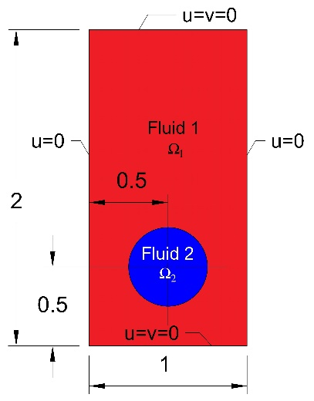

**Fig. 8** The initial configuration and boundary conditions for the rising bubble problem.

A 0.5 m diameter bubble of fluid 2 is positioned at (0.5, 0.5) m within a tank of 1 x 2 m filled with fluid 2. The top and bottom walls are defined as no-slip boundary conditions and the vertical walls as symmetry boundary conditions. The density and dynamic viscosity of fluid 1 are ρ1=1000 kg/m3 and μ1=10 kg/(m.s), and for fluid 2 ρ2=100 kg/m3 and μ2=1 kg/(m.s). The dynamic of the bubble is controlled by a gravity force g=-0.98 m/s2 and a surface tension coefficient σ=24.5 N/m. The benchmark quantities are the temporal evolution during three seconds of the center of mass of the bubble and its mean rising velocity which are determined as

 (32)

where *Ω2* denotes the region that the bubble occupies and *δV* size of the control volume.

The above quantities are used to validate the multiphase code and also the quality of the overall solution method. The error of the simulation is quantified using the following relative error norm:

 (33)

where qt is the temporal evolution of the quantity *xc* or *yc*, and *qref* is the reference solution presented in (Hysing et al., 2009).

The computation is performed for three uniform structured grids which consist of 40x80, 80x160, and 160x320 hexahedral control volumes. The time steps selected for each mesh are 0.02 s, 0.01 s, and 0.005 s respectably. This selection results in a maximum local Co of 0.45 for the three grids. The convergence criterion is *ζ* =5x10-4 for the volume fraction field and *ζ****u*** =10-6 for the velocity field. The curvature is calculated with the height-function method (Malik, Fan, & Bussmann, 2007).

Fig. 9 shows the total number of iterations for the coarse, medium, and fine grid during three seconds of the calculation for the six HR schemes implemented using the DC, DWF, RNWF, and MNWF methods. For the three girds in this test case, the efficiency of the DC, DWF, RNWF and MNWF methods are similar for CICSAM and MCICSAM-Z. Although for the coarse and medium grid, the RNWF seems to have a small advantage. On the other hand, for the three grids and the other HR schemes, the percentage difference between the four methods is similar. The MNWF method is 15-27% faster than DC, 6-13% than RNWF, and 20-50% than DWF. Although the most influential part of this simulation is the calculation of the curvature, the effects of the implementation techniques remained, and again the MNWF shows the best performance and DWF the worst.



**Fig. 9** The total number of iterations for a) coarse grid, b) medium grid, and c) fine grid for the rising bubble test case. The six blended HR schemes implemented through the DC, DWF, RNWF, and MNWF method are presented.

Besides that, the relative error of the results computed for the fine grid, presented in Table 4, reveals that the calculations performed using the MNWF method are in the same range of precision than with the other methods. Fig. 10 a) shows the final position of the bubble solved with the CUIBS scheme in combination with MNWF for the fine grid, and b), the evolution of the center of mass with time, and c) the rise velocity of the bubble for the six blended HR schemes implemented with the MNWF method.

**Table 4**  Relative error norm for the rising bubble test case solved using the different HR schemes and the implementation techniques for the fine grid.

|  |  |  |  |  |  |  |  |  |
| --- | --- | --- | --- | --- | --- | --- | --- | --- |
| Implement.  method  HR scheme | Center of the mass [x10-3] | | | | Rising velocity [x10-3] | | | |
| DC | DWF | RNWF | MNWF | DC | DWF | RNWF | MNWF |
| CICSAM | 4.67 | 4.69 | 4.69 | 4.69 | 3.52 | 3.52 | 3.50 | 3.42 |
| MCICSAM-W | 3.67 | 3.70 | 3.69 | 3.67 | 11.00 | 11.00 | 10.90 | 11.00 |
| MCICSAM-Z | 3.39 | 3.39 | 3.14 | 3.23 | 3.32 | 3.32 | 3.25 | 3.24 |
| HRIC | 4.67 | 4.69 | 4.69 | 4.69 | 14.80 | 14.80 | 14.60 | 14.90 |
| FBICS | 3.28 | 3.30 | 3.26 | 3.26 | 4.24 | 4.25 | 4.23 | 4.27 |
| CUIBS | 3.27 | 3.29 | 3.30 | 3.28 | 4.08 | 4.08 | 4.04 | 4.08 |

|  |  |  |
| --- | --- | --- |
| a) | b) | c) |
|  |  |  |

**Fig. 10** a) Final position of the bubble at 3s calculated using the CUIBS scheme in combination with the MNWF method for the fine grid. b) Center of mass and c) rise velocity of the rising bubble during 3s for the six blended HR schemes implemented employing the new MNWF method for the fine grid. The Reference refers to the results of (Hysing et al., 2009).

**7.3.1 3D Rising bubble**

In order to measure the efficiency of the new approach in 3D scenarios, the 2D rising bubble test case was extended to 3D according to the configuration showed in (Turek, Mierka, & Bäumler, 2019). The physical properties, gravity, and surface tension coefficient are the same as for the 2D case. Only now all walls are set as non-slip boundary conditions. The computational domain is a uniform structured grid of 80x80x160 hexahedral control volumes divided into 32 blocks. The time step is 0.005 s which produces a maximum Co~0.55. The curvature is calculated with the standard second-order central difference scheme (CDS). The convergence criterion is *ζ* =5x10-4 for the volume fraction and *ζ****u*** =10-7 for the velocity. For this part, the results obtained with CICSAM, and MCICSAM-Z are not presented because their low performance shown in the 2D case is almost the same in the 3D case, and these impede the precise observation of the other results. Fig. 11 shows the new initial geometric configuration, the simulation results of the position of the bubble at three seconds, and the evolution of the rise velocity. The four schemes MCICSAM-W, HRIC, FBICS, CUIBS, implemented with the MNWF method agree with the reference result published in Turek et al. ( 2019).

|  |  |  |
| --- | --- | --- |
| a) | b) | c) |

**Fig. 11** a)Geometric initial configuration for the 3D rising bubble test case, b) bubble position at 3s. The lines depict the division into blocks of the grid. c) Temporal evolution of the rise velocity of the center of the bubble obtained with four methods implemented with MNWF and the reference results computed with NaSt3D, OpenFOAM, and FeatFlow.

Concerning the efficiency of the MNWF method, the performance shown for the 2D case is almost the same for the 3D case. The MNWF method is the fastest and the DWF method the slowest. Except for the FBICS scheme where the quickest is the DC. See Fig. 12.



**Fig. 12** The total number of iterations for the 3D rising bubble test case for the four blended HR schemes implemented using the DC, DWF, RNWF, and MNWF method.

**7.4 The** **dam break flow impacting a rigid structure**

Finally, to validate our proposed MNWF method for more realistic applications, the classic dam breaking example is computed. It was experimentally studied by (Koshizuka, 1995) to describe the collapse of a water column impacting a rigid structure. Fig. 13 represents the geometry and physical parameters of the problem. It consists of a box open to the atmosphere that contains a water column which collapses and hits a rigid obstacle. The high-density fluid is water, and the low-density fluid is air, both with standard physical properties. The two-phase flow is considered laminar, and the surface tension effects are neglected.

|  |  |
| --- | --- |
| a) | b) |
|  |  |

**Fig. 13** a) Geometrical configuration and physical parameters of the dam break flow impacting a rigid structure test case. The dimensions are in mm. b) Initial condition in the coarse computational domain.

The computation is run for two grids consisting of hexahedral control volumes (CV), a coarse grid of 2384 CV and a fine grid of 9536 CV. Each mesh is formed by five blocks divided according to the contour of the obstacle and following a hyperbolic distribution as is shown in Fig.13 b). The simulations are computed for 0.9 seconds with a variable time-step defined for each grid to maintain a Co below one. For these calculations, the adaptative time step is chosen because the kinematic energy of the water increases with the time, which produces a constant increase of the Courant number. If a small constant time step is selected, the calculation is stable but is inefficient, while a large value leads to divergence when the velocity of the water is higher. The convergence criterion for the volume fraction field is *ζ* =5x10-4, and *ζ****u*** =10-7 for the velocity and pressure.

Fig. 14 presents the total number of iterations required in each grid for the six HR schemes implemented using DC, DWF, RNWF, and MNWF. For the two grids, the difference in the performance of the methods is less evident than for the other cases. It is because the timing control results in low courant numbers over a large part of the simulation period. Thus, decreasing the difference in efficiency that exists between the methods. As shown in the first case, the advection of a Slotted Circle in a rotational flow, for low Co, all four methods act similarly. However, for these grids, one observes that for the CICSAM and MCICSAM-Z schemes, the new MNWF method is considerably better than DC and DWF, and slightly better than RNWF. Although RNWF is the quickest for MCICSAM-Z in the coarse grid domain. MNWF computed results with 31-44% fewer iterations than DC, 50% fewer than DWF, and 2-25% fewer than RNWF.

Meanwhile, for MCICSAM-W, HRIC, FBICS and CUIBS, the advantage in speed of MNWF in comparison with the other techniques is less evident but existent. The MNWF is approximately 5-7% faster than DC or RNWF, and 15-32% than DWF. Furthermore, in this case, we noted that the numerical precision of the implementation method directly affects the calculation of the velocity. Thus, the velocity needs more interactions to converge, especially for DWF as this method on many occasions does not achieve the converge criterion.



**Fig. 14** The total number of iterations required for the six HR schemes implemented using the DC, DWF, RNWF, and MNWF method. The simulations of the dam-break flow impacting a rigid structure case were calculated for 0.9 s.

Finally, in Fig. 14, a qualitative comparison between the simulation results obtained for the fine grid using the MCICSAM-Z scheme implemented with the proposed method MNWF and the experimental results from Koshizuka (1995) are presented to demonstrate the quality of the simulations.

|  |  |
| --- | --- |
|  | t = 0s |
|  | t = 0.25s |
|  | t = 0.3s |
|  | t = 0.4 s |
|  | t = 0.5 s |

**Fig. 15** A comparison of the free surface profile in the dam break experiment of Koshizuka (1995) at the same snapshot times. The results were obtained using the MCICSAM-Z scheme implemented with our new modified normalized weighting factor (MNWF) method.

* **Conclusions**

We presented a new methodology, the MNWF method, to deal with the implementation of blended HR schemes in the context of multiphase flow. The method is based on the NWF methodology and produces a system of tridiagonal equations. The resulting coefficient matrix is always diagonally dominant, with Ap coefficients greater than zero, giving a numerically stable method without the necessity of under relaxation. The main advantage of the new approach is its high rate of convergence in comparison to the other methods studied in this work, the DC, DWF, and RNWF methods. Also, MNWF does not degenerate the interface.

The superiority in the rate of convergence of the new MNWF compared to the other methods depends on the test case. However, generally, it can be concluded that the MNWF is about 5-25% faster than the DC and RNWF methods, and markedly quicker than the DWF method. For medium and high Co cases, this difference exceeded 80% because the DWF method in many occasions does not converge, and the maximum number of iterations is executed. Thus, confirming what was mentioned by Darwish & Moukalled (1996), that the coefficients generated with the DWF form a numerically unstable system of equations.

Additionally, we observed that the convergence rate is strongly influenced by the methodology used to implement the blended HR schemes for medium and high local Co. Especially in the case of CICSAM and its modifications, which were initially developed to be implemented with the DWF method.

Also, observing the number of iterations for the three refined grids in the 2D rising bubble and in the dam break flow impacting a rigid structure test cases, we can conclude that the methodology is independent of the grid size, and the most influential parameter is the Courant number.

On the other hand, the accuracy of the results does not seem to be affected by the methodology used to implement the schemes numerically. Instead, it seems to be a characteristic of each scheme. Except for CICSAM, which generates less accurate results if it is implemented with RNWF.

In summary, the new MNWF methodology is highly recommended to work with medium and high Co as well as to improve the stability of the blended HR schemes.

**Table 1**: Example of the construction of one table

| C11 | C12 | C13 |
| --- | --- | --- |
| C21 | C22 | C23 |
| C31 | C32 | C33 |
| C41 | C42 | C43 |
| C51 | C52 | C53 |

* 1. **Test cases**
  2. **Influence of the high-resolution scheme properties on the results**

1. **Novel implementation method**
2. **Flow with FSI**
3. **Case studies**
   1. **Verification of the single-phase code (mms)**
   2. **Verification of the two-phase flow code**
   3. **Validation of the single-phase code (steady lid-drive cavity, poiselon laminar, unsteady cylinder)**
   4. **Pressure analysis**
   5. **Spurious velocity analysis**
4. **Conclusion**
5. **TEST CASES**

**MULTIPHASE FLOWS**

* 1. **Rayleigh–Taylor instability**

(Queutey & Visonneau, 2007)

If a heavy fluid of density ρ2 is superimposed on a lighter fluid of density ρ1 in a vertical gravity field g, unstable growth of disturbances along the interface occurs. This phenomenon is known as Rayleigh-Taylor instability. For the case of viscous flow with the same viscosity (), the analytical results of the early phase of unstable growth was obtained by Chandrasekhar (Chandrasekhar, 2013) who showed that instability is a function of density radio, gravitational acceleration and kinematic viscosity. In fact, he predicts the variation of growth rate  (inverse time units), the wavenumber  (inverse distance units), and an expression of Reynolds number from these units that is expressed as . The purpose of this section is to compare our results with his prediction.

The test setting are according the recommendation of (Daly, 1967; Queutey & Visonneau, 2007). The computational domain is a 2D rectangle [0, 0.02] x [-0.03, 0.03] m2 with a uniform grid of 40 x 120. The left, right, bottom, and top are treated as slip boundary condition. Initially, the interface is located at y = 0, and a single wavelength perturbation is introduced through the following velocity field



where A is the amplitude of the perturbation, L=λ/2 is the half wavelength of the perturbation and corresponds to the width of the mesh, δy is the mesh spacing in the y direction and H(y) is the Heaviside function given by.



The numerical results are determined for a density ratio, 2:1, the density of the lighter fluid ρ1=1 kg/m3,gravity g = -1 m/s, perturbation amplitude A= 0.1. This setting allows to show the capability of the method for capturing wave breaking since the interface rolls up, yielding the mushroom pattern typical of this problem. Three Reynolds numbers 39, 72, and 176 are tested. Fig. # shows the position of the interface at four different times for Re=72 ().

Re=72 nu=0.00011

Re=39 nu=0.000205

Re=176 nu=0.00004545

Fig # depicts the temporal evolution of the logarithm of instability amplitudes for the computation at above Reynolds numbers. The amplitude is determined as the average of the absolute displacements of the interface along the left and right vertical walls. The slope of these amplitude logarithms measures the exponential growth rate n of the instabilities. The slope is only measure in the linear region of the curve to avoid the transient modes of the early phase of instability. The growth rate obtained by (Queutey & Visonneau, 2007) is 3.5, 4.7, and 5.5 for Reynolds numbers 39, 72, 176, respectively, and were close to the values obtained by Daly [38]: 3.6, 4.5 and 5.6 for the same Reynolds numbers.

In Fig. #, the growth rates are plotted in dimensionless form n against Reynolds number and are compared with the analytical prediction of Chandrasekhar. A excellent overall agreement with the theoretical curve is observed.

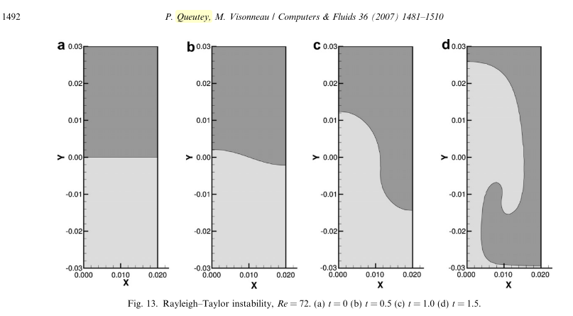

3D Rising bubble

The 3D Rising bubble of (Turek et al., 2019) is a extension of the multiphase flow benchmark cases of (Hysing et al., 2009). In a tank full of fluid 1 a bubble of fluid 2 is situated which rises by the effects of gravity. Fig. # illustrates the initial geometric configuration of the problem. All walls are set as no-slip boundary conditions. The density and dynamic viscosity of fluid 1 are ρ1=1000 kg/m3 and μ1=10 kg/(m.s), and for fluid 2 ρ2=100 kg/m3 and μ2=1 kg/(m.s). The gravity force is g=-0.98 m/s2 and the surface tension coefficient is σ=24.5 N/m.

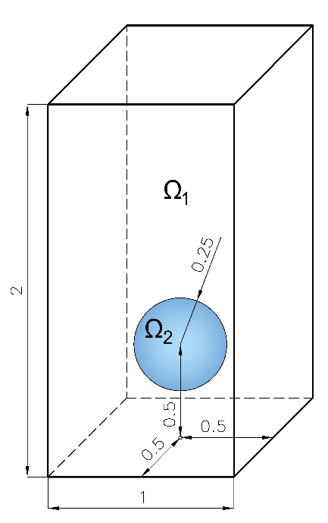

* **Fig. 8** Initial configuration and boundary conditions for the rising bubble problem.

The amounts to compare are the bubble size in two different directions and the rise velocity. The size in the rise direction (z) is determined as  , and at the perpendicular to rise direction aligned with the x-axis is . R0 is the initial bubble size. The rise velocity is defined as

*  (32)

where *Ω2* denotes the region that the bubble occupies and *δV* size of the control volume.

The computational domain is a uniform structured grid of 80x80x160 hexahedral control volumes, and the time step is 0.005 s. The curvature is calculated with ++++.





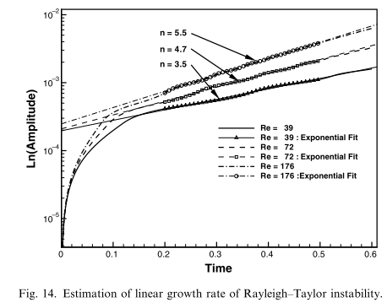

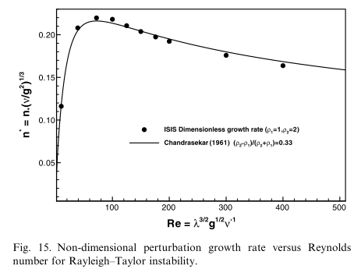

**fsi3**

The domain is discretized with a structural grid consists of 11 blocks. The coarse mesh consists of 15232 CV, the medium of 60 928 CV, and the fine of 243 712 CV. For the structural part, the number of elements were 32x4, 64x4, 128x4 respectively. The type of element used was the linear 8 node brick element (C3D8) for all the cases. The shape function can be found in (Lapidus & Pinder, 1982)





**dam BREAK WITH ELASTIC OBSTRUCTION**

**FSI involving free surface flows.**

To validate the new approach, I use the collapsing column of water, hitting an elastic wall, case previously analyzed in (Pin et al., 2007; Walhorn et al., 2005; INSERTAR WALL). The initial configuration is shown in Figure 4. It consists of a 292 mm column of water that collapse under gravity hitting an 80x12 mm2 elastic wall. The tank is open at the top and surface tension are ignored due to the large length scales. The dam break problem presents conceptually difficulties for the QN methods. Before the hitting of the advance front, the coupling algorithms spend several time steps training the interface Jacobians given a very low loading condition, following by a very sharp and abrupt increase in interface forces. Nevertheless (Bogaers et al., 2016) demonstrated that the QL methods can deal with problems with abrupt changes in the magnitude of fluid forces. The snapshots of various time-steps of the advancing of the front with the elastic deformation is presented in Figure 5.

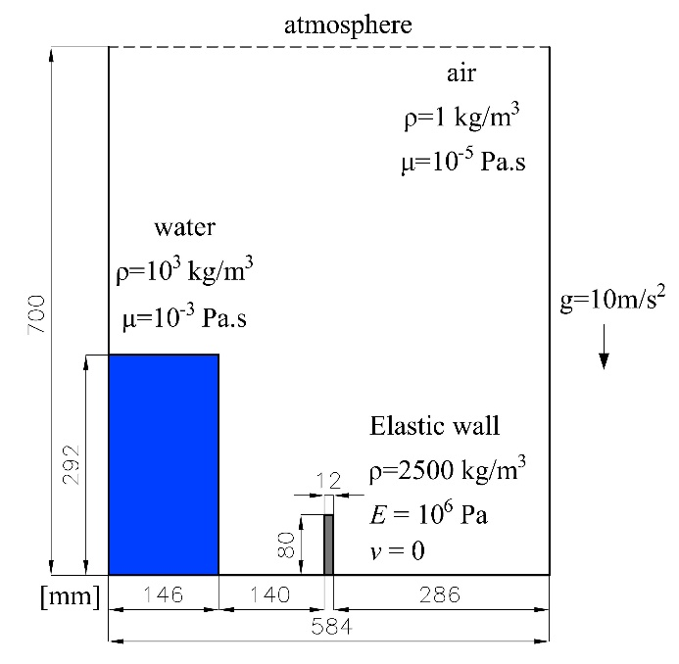

Figure 4 Dam-break with elastic structure geometric configuration

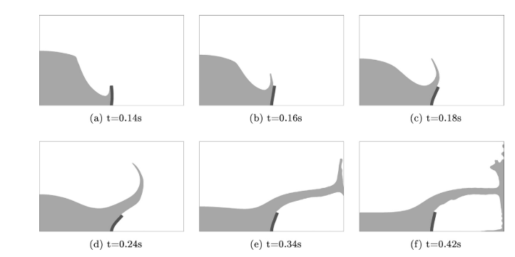

Figure 5 Wave iteration with elastic structure at various time-steps

The domain of the problem is discretized for two block structure meshes. The first consist of 3672 control volumes and 16 quadratic, full integration solid elements, with time step sizes of 0.001s. The fines mesh consists of 30340 control volumes and 112 quadratic, full integrated solid elements, using a time-step size of 0.0005s.

According (Haelterman, Bogaers, Scheufele, Uekermann, & Mehl, 2016) if the number of retains time step is too large or two small, results in either divergence or a deteriorated performance. However, the use of filters improves the stability and performance of the QN-LS family of methods.

Collapsing arch WALL (Wall et al., 2007)

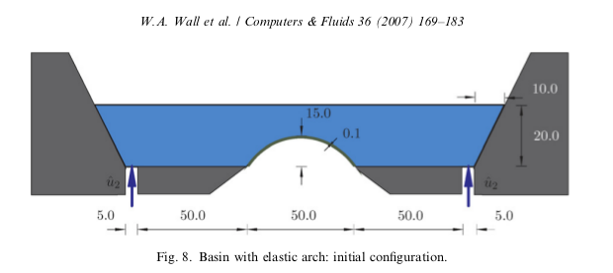

**12 CONCLUSIONS**

**ACKNOWLEDGMENTS**

This work is supported by the “Excellence Initiative” of the German Federal and State Governments within the Graduate School of Computational Engineering at Technische Universität Darmstadt.

**REFERENCES**

Akkerman, I., Bazilevs, Y., Benson, D. J., Farthing, M. W., & Kees, C. E. (2012). Free-Surface Flow and Fluid-Object Interaction Modeling With Emphasis on Ship Hydrodynamics. *Journal of Applied Mechanics*, *79*(1), 010905. https://doi.org/10.1115/1.4005072

Aleinov, I., & Puckett, E. G. (1995). Computing surface tension with high-order kernels. *Proceedings of the 6th International Symposium on Computational Fluid Dynamics*, 13–18.

Arıcı, M., Şinasi Onur, H., Arici, M., & Şinasi Onur, H. (2011). Performance comparison of high resolution schemes. *Proceedings of the 6th International Conference on Computational Fluid Dynamics, ICCFD 2010*, 527–533. https://doi.org/10.1007/978-3-642-17884-9-66

Ashgriz, N., & Poo, J. Y. (1991). FLAIR: Flux line-segment model for advection and interface reconstruction. *Journal of Computational Physics*. https://doi.org/10.1016/0021-9991(91)90194-P

Bai, X., Avital, E. J., Munjiza, A., & Williams, J. J. R. (2014). Numerical simulation of a marine current turbine in free surface flow. *Renewable Energy*, *63*, 715–723. https://doi.org/10.1016/j.renene.2013.09.042

Basting, S., & Weismann, M. (2013). A hybrid level set-front tracking finite element approach for fluid-structure interaction and two-phase flow applications. *Journal of Computational Physics*. https://doi.org/10.1016/j.jcp.2013.08.018

Bogaers, A. E. J., Kok, S., Reddy, B. D., & Franz, T. (2016). An evaluation of quasi-Newton methods for application to FSI problems involving free surface flow and solid body contact. *Computers & Structures*, *173*, 71–83. https://doi.org/10.1016/j.compstruc.2016.05.018

Brackbill, J. ., Kothe, D. ., & Zemach, C. (1992). A continuum method for modeling surface tension. *Journal of Computational Physics*, *100*(2), 335–354. https://doi.org/10.1016/0021-9991(92)90240-Y

Bungartz, H.-J., Lindner, F., Gatzhammer, B., Mehl, M., Scheufele, K., Shukaev, A., & Uekermann, B. (2016). preCICE – A fully parallel library for multi-physics surface coupling. *Computers & Fluids*, *141*, 250–258. https://doi.org/10.1016/j.compfluid.2016.04.003

Chandrasekhar, S. (2013). *Hydrodynamic and hydromagnetic stability*. Courier Corporation.

Chourushi, T. (2018). Computationally inexpensive and revised normalized weighting factor method for segregated solvers. *International Journal of Computer Mathematics*, *95*(8), 1622–1653. https://doi.org/10.1080/00207160.2017.1324151

Daly, B. J. (1967). Numerical Study of Two Fluid Rayleigh-Taylor Instability. *Physics of Fluids*, *10*(2), 297. https://doi.org/10.1063/1.1762109

Darwish, M., & Moukalled, F. (1996). The normalized weighting factor method: a novel technique for accelerating the convergence of high-resolution convective schemes. *Numerical Heat Transfer, Part B: Fundamentals*, *30*(2), 217–237. https://doi.org/10.1080/10407799608915080

Darwish, M., & Moukalled, F. (2006). Convective Schemes for Capturing Interfaces of Free-Surface Flows on Unstructured Grids. *Numerical Heat Transfer, Part B: Fundamentals*, *49*(1), 19–42. https://doi.org/10.1080/10407790500272137

Davis, S. F. (1994). Flux difference splittings and limiters for the resolution of contact discontinuities. *Applied Mathematics and Computation*. https://doi.org/10.1016/0096-3003(94)90162-7

Degroote, J., Bathe, K. J., & Vierendeels, J. (2009). Performance of a new partitioned procedure versus a monolithic procedure in fluid-structure interaction. *Computers and Structures*, *87*(11–12), 793–801. https://doi.org/10.1016/j.compstruc.2008.11.013

Demirdžić, I., & Perić, M. (1988). Space conservation law in finite volume calculations of fluid flow. *International Journal for Numerical Methods in Fluids*, *8*(9), 1037–1050. https://doi.org/10.1002/fld.1650080906

Fernández, M. A., & Moubachir, M. (2005). A Newton method using exact jacobians for solving fluid-structure coupling. *Computers and Structures*. https://doi.org/10.1016/j.compstruc.2004.04.021

Ferziger, J. H., & Peric, M. (2012). *Computational methods for fluid dynamics* (3rd ed.). New York: Springer-Verlag Berlin Heidelberg New.

Flitz, F., Sternel, D., & Schäfer, M. (2011). The influence of different time integration schemes in ALE description applied to moving meshes. *IV International Conference on Computational Methods for Coupled Problems in Science and Engineering*.

Fraggedakis, D., Papaioannou, J., Dimakopoulos, Y., & Tsamopoulos, J. (2017). Discretization of three-dimensional free surface flows and moving boundary problems via elliptic grid methods based on variational principles. *Journal of Computational Physics*, *344*, 127–150. https://doi.org/10.1016/j.jcp.2017.04.060

Gaskell, P. H., & Lau, A. K. C. (1988). Curvature-compensated convective transport: SMART, A new boundedness- preserving transport algorithm. *International Journal for Numerical Methods in Fluids*, *8*(6), 617–641. https://doi.org/10.1002/fld.1650080602

Gillebaart, T., Blom, D. S., van Zuijlen, A. H., & Bijl, H. (2016). Time consistent fluid structure interaction on collocated grids for incompressible flow. *Computer Methods in Applied Mechanics and Engineering*, *298*, 159–182. https://doi.org/10.1016/j.cma.2015.09.025

Haelterman, R., Bogaers, A. E. J., Scheufele, K., Uekermann, B., & Mehl, M. (2016). Improving the performance of the partitioned QN-ILS procedure for fluid–structure interaction problems: Filtering. *Computers & Structures*, *171*, 9–17. https://doi.org/10.1016/j.compstruc.2016.04.001

Hino, T. (2006). CFD-based estimation of propulsive performance in ship design. *26th Symposium on Naval Hydrodynamics*. Rome.

Hirt, C. ., & Nichols, B. . (1981). Volume of fluid (VOF) method for the dynamics of free boundaries. *Journal of Computational Physics*, *39*(1), 201–225. https://doi.org/10.1016/0021-9991(81)90145-5

Hoekstra, M. (1998). PARNASSOS: An efficient method for ship stern flow calculation. *Third Osaka Colloquium on Advanced CFD Applications to Ship Flow and Hull Form Design*, 331–357.

Hoekstra, M., Vaz, G., Abeil, B., & Bunnik, T. (2007). Free-surface flow modelling with interface capturing techniques. *MARINE 2007*, *2*, 1–4. Retrieved from http://www.marin.nl

Hogg, P. W., Gu, X.-J. J., & Emerson, D. R. (2006). An implicit algorithm for capturing sharp fluid interfaces in the volume of fluid advection method. *European Conference on Computational Fluid Dynamics ECCOMAS CFD*.

Hou, G., Wang, J., & Layton, A. (2012). Numerical Methods for Fluid-Structure Interaction — A Review. *Communications in Computational Physics*, *12*(2), 337–377. https://doi.org/10.4208/cicp.291210.290411s

Hu, Z., Tang, W., Xue, H., Zhang, X., & Wang, K. (2017). Numerical study of rogue wave overtopping with a fully-coupled fluid-structure interaction model. *Ocean Engineering*, *137*, 48–58. https://doi.org/10.1016/j.oceaneng.2017.03.022

Hysing, S., Turek, S., Kuzmin, D., Parolini, N., Burman, E., Ganesan, S., & Tobiska, L. (2009). Quantitative benchmark computations of two-dimensional bubble dynamics. *International Journal for Numerical Methods in Fluids*, *60*(11), 1259–1288. https://doi.org/10.1002/fld.1934

J. D. Anderson, John, D., & Anderson, J. R. (1995). Computational Fluid Dynamics: the Basics with Applications. In *P. Perback, International ed., Published*. https://doi.org/10.1017/S0001924000067129

Jasak, H., Weller, H. G., & Gosman, A. D. (1999). High resolution NVD differencing scheme for arbitrarily unstructured meshes. *International Journal for Numerical Methods in Fluids*, *31*(2), 431–449. https://doi.org/10.1002/(SICI)1097-0363(19990930)31:2<431::AID-FLD884>3.0.CO;2-T

Kaplan, P. (1992). Wave Impact Forces on Offshore Structures: Re-Examination and New Interpretations. *Offshore Technology Conference*. https://doi.org/10.4043/6814-MS

Kassiotis, C., Ibrahimbegovic, A., & Matthies, H. (2010). Partitioned solution to fluid–structure interaction problem in application to free-surface flows. *European Journal of Mechanics - B/Fluids*, *29*(6), 510–521. https://doi.org/10.1016/j.euromechflu.2010.07.003

Koshizuka, S. (1995). A particle method for incompressible viscous flow with fluid fragmentation. *Comput. Fluid Dyn. J.*, *4*(29).

Koshizuka, S., & Oka, Y. (1996). Moving-Particle Semi-Implicit Method for Fragmentation of Incompressible Fluid. *Nuclear Science and Engineering*, *123*(3), 421–434. https://doi.org/10.13182/NSE96-A24205

Kothe, D. B. (1998). Perspective on Eulerian Finite Volume Methods for Incompressible Interfacial Flows. In *Free Surface Flows*: *Vol.* *M* (pp. 267–331). https://doi.org/10.1007/978-3-7091-2598-4_6

Küttler, U., & Wall, W. A. (2008). Fixed-point fluid–structure interaction solvers with dynamic relaxation. *Computational Mechanics*, *43*(1), 61–72. https://doi.org/10.1007/s00466-008-0255-5

Lapidus, L., & Pinder, G. F. (1982). *Numerical solution of partial differential equations in science and engineering*. New York: John Wiley & Sons.

Lee, C.-S., Cho, J.-R., Kim, W.-S., Noh, B.-J., Kim, M.-H., & Lee, J.-M. (2013). Evaluation of sloshing resistance performance for LNG carrier insulation system based on fluid-structure interaction analysis. *International Journal of Naval Architecture and Ocean Engineering*, *5*(1), 1–20. https://doi.org/10.3744/JNAOE.2013.5.1.001

Leonard, B. P. (1979). A stable and accurate convective modelling procedure based on quadratic upstream interpolation. *Computer Methods in Applied Mechanics and Engineering*, *19*(1), 59–98. https://doi.org/10.1016/0045-7825(79)90034-3

Leonard, B. P. (1991). The ULTIMATE conservative difference scheme applied to unsteady one-dimensional advection. *Computer Methods in Applied Mechanics and Engineering*, *88*(1), 17–74. https://doi.org/10.1016/0045-7825(91)90232-U

Leonard, B. P., & Mokhtari, S. (1990). Beyond first-order upwinding: The ultra-sharp alternative for non-oscillatory steady-state simulation of convection. *International Journal for Numerical Methods in Engineering*, *30*(4), 729–766. https://doi.org/10.1002/nme.1620300412

Liao, K., Hu, C., & Sueyoshi, M. (2015). Free surface flow impacting on an elastic structure: Experiment versus numerical simulation. *Applied Ocean Research*, *50*, 192–208. https://doi.org/10.1016/j.apor.2015.02.002

López, I., Pereiras, B., Castro, F., & Iglesias, G. (2014). Optimisation of turbine-induced damping for an OWC wave energy converter using a RANS–VOF numerical model. *Applied Energy*, *127*, 105–114. https://doi.org/10.1016/j.apenergy.2014.04.020

Lötstedt, P. (1982). A front tracking method applied to Burgers’ equation and two-phase porous flow. *Journal of Computational Physics*. https://doi.org/10.1016/0021-9991(82)90075-4

Main, A., & Farhat, C. (2014). A second-order time-accurate implicit finite volume method with exact two-phase Riemann problems for compressible multi-phase fluid and fluid-structure problems. *Journal of Computational Physics*. https://doi.org/10.1016/j.jcp.2013.11.001

Majumdar, S. (1988). ROLE OF UNDERRELAXATION IN MOMENTUM INTERPOLATION FOR CALCULATION OF FLOW WITH NONSTAGGERED GRIDS. *Numerical Heat Transfer*, *13*(1), 125–132. https://doi.org/10.1080/10407788808913607

Maliska, C., & Raithby, G. (1983). Calculating three-dimensional fluid flows using nonorthogonal grids. *Third International Conference on Numerical Methods in Laminar and Turbulent Flows*, 656–666. Seattle.

Mehl, M., Uekermann, B., Bijl, H., Blom, D., Gatzhammer, B., & van Zuijlen, A. (2016). Parallel coupling numerics for partitioned fluid–structure interaction simulations. *Computers & Mathematics with Applications*, *71*(4), 869–891. https://doi.org/10.1016/j.camwa.2015.12.025

Mencinger, J. (2012). An Alternative Finite Volume Discretization of Body Force Field on Collocated Grid. In *Finite Volume Method - Powerful Means of Engineering Design*: *Vol.* *Di*. https://doi.org/10.5772/38813

Mencinger, J., & Žun, I. (2007). On the finite volume discretization of discontinuous body force field on collocated grid: Application to VOF method. *Journal of Computational Physics*, *221*(2), 524–538. https://doi.org/10.1016/j.jcp.2006.06.021

Mencinger, J., & Žun, I. (2011). A PLIC–VOF method suited for adaptive moving grids. *Journal of Computational Physics*, *230*(3), 644–663. https://doi.org/10.1016/j.jcp.2010.10.010

Meyer, J., Renzsch, H., Graf, K., & Slawing, T. (2016). Advanced CDF-Simulations of free-surface flows around modern sailing yachts using a newly developed OpenFOAM solver. *THE 22nd CHESAPEAKE SAILING YACHT SYMPOSIUM*. ANNAPOLIS.

Mok, D.P., Wall, W.A., & Ramm, E. (2001). Accelerated iterative substructuring schemes for instationary fluid-structure interaction. *Computational Fluid and Solid Mechanics*, 1325–1328. Elsevier.

Moukalled, F. H., Mangani, L. (Luca), & Darwish, M. (Marwan). (2016). Discretization of the Convection Term. In *The Finite Volume Method in Computational Fluid Dynamics* (p. 791).

Moukalled, F, Mangani, L., & Darwish, M. (2016). *The Finite Volume Method in Computational Fluid Dynamics*. https://doi.org/10.1007/978-3-319-16874-6

Moukalled, Fadl, Mangani, L., & Darwish, M. (2016). Implementation of boundary conditions in the finite-volume pressure-based method—Part I: Segregated solvers. *Numerical Heat Transfer, Part B: Fundamentals*, *69*(6), 534–562. https://doi.org/10.1080/10407790.2016.1138748

Muzaferija, S., & Peric, M. (1998). Computation of free-surface flows using interface-tracking and interface-capturing methods. *Computational Mechanics*, (Nonlinear water-wave interaction). Retrieved from https://www.researchgate.net/publication/320979291

Muzaferija, S., & Perić, M. (1999). A Two-Fluid Navier-Stokes Solver to Simulate Water Entry. *Proceedings of 22nd Symposium on Naval Hydrodynamics*, 638–651. Washington: National Academy Press.

Nicolici, S., & Bilegan, R. M. M. (2013). Fluid structure interaction modeling of liquid sloshing phenomena in flexible tanks. *Nuclear Engineering and Design*, *258*, 51–56. https://doi.org/10.1016/j.nucengdes.2012.12.024

Noh, W. F., & Woodward, P. (1976). *SLIC (Simple Line Interface Calculation)*. https://doi.org/10.1007/3-540-08004-X_336

Osher, S., & Fedkiw, R. P. (2001). Level Set Methods: An Overview and Some Recent Results. *Journal of Computational Physics*. https://doi.org/10.1006/jcph.2000.6636

Osher, S., & Sethian, J. A. (1988). Fronts propagating with curvature-dependent speed: Algorithms based on Hamilton-Jacobi formulations. *Journal of Computational Physics*, *79*(1), 12–49. https://doi.org/10.1016/0021-9991(88)90002-2

Paik, K.-J., & Carrica, P. M. (2014). Fluid–structure interaction for an elastic structure interacting with free surface in a rolling tank. *Ocean Engineering*, *84*, 201–212. https://doi.org/10.1016/j.oceaneng.2014.04.016

Park, I. R., Kim, K. S., Kim, J., & Van, S. H. (2009). A volume-of-fluid method for incompressible free surface flows. *International Journal for Numerical Methods in Fluids*, *61*(12), 1331–1362. https://doi.org/10.1002/fld.2000

Patankar, S. V. (1980). *Numerical Heat Transfer and Fluid Flow*. Retrieved from https://www.taylorfrancis.com/books/9781482234213

Patel, J. K., & Natarajan, G. (2015). A generic framework for design of interface capturing schemes for multi-fluid flows. *Computers & Fluids*, *106*, 108–118. https://doi.org/10.1016/j.compfluid.2014.10.005

Pedersen, P. T. (2015). Marine Structures: Future Trends and the Role of Universities. *Engineering*, *1*(1), 131–138. https://doi.org/10.15302/J-ENG-2015004

Pilliod, J. E., & Puckett, E. G. (2004). Second-order accurate volume-of-fluid algorithms for tracking material interfaces. *Journal of Computational Physics*, *199*(2), 465–502.

Pin, F. Del, Idelsohn, S., Oñate, E., & Aubry, R. (2007). The ALE/Lagrangian Particle Finite Element Method: A new approach to computation of free-surface flows and fluid–object interactions. *Computers & Fluids*, *36*(1), 27–38. https://doi.org/10.1016/j.compfluid.2005.06.008

Prasad, B., Hino, T., & Suzuki, K. (2015). Numerical simulation of free surface flows around shallowly submerged hydrofoil by OpenFOAM. *Ocean Engineering*, *102*, 87–94. https://doi.org/10.1016/j.oceaneng.2015.04.049

Queutey, P., & Visonneau, M. (2007). An interface capturing method for free-surface hydrodynamic flows. *Computers & Fluids*, *36*(9), 1481–1510. https://doi.org/10.1016/j.compfluid.2006.11.007

Rhie, C. M. (1985). A three-dimensional passage flow analysis method aimed at centrifugal impellers. *Computers & Fluids*, *13*(4), 443–460. https://doi.org/10.1016/0045-7930(85)90013-1

Rubin, S., & Khosla, P. (1977). Polynomial interpolation methods for viscous flow calculations. *Journal of Computational Physics*, *24*(3), 217–244. https://doi.org/10.1016/0021-9991(77)90036-5

Rudman, M. (1997). VOLUME-TRACKING METHODS FOR INTERFACIAL FLOW CALCULATIONS. *International Journal for Numerical Methods in Fluids*, *24*(7), 671–691. https://doi.org/10.1002/(SICI)1097-0363(19970415)24:7<671::AID-FLD508>3.0.CO;2-9

Sauer, J. (2000). *Instationär kavitierende Strömungen: ein neues Modell, basierend auf front capturing (VoF) und Blasendynamik*. Universität Karlsruhe.

Schäfer, M, Sternel, D. C., Becker, G., & Pironkov, P. (2011). Efficient Numerical Simulation and Optimization of Fluid-Structure Interaction. In *Fluid Structure Interaction II* (pp. 131–158). Retrieved from www.fnb.tu-darmstadt.de

Schäfer, Michael. (2006). Computational engineering - Introduction to numerical methods. In *Computational Engineering - Introduction to Numerical Methods*. https://doi.org/10.1007/3-540-30686-2

Schäfer, Michael, Heck, M., & Yigit, S. (2006). An Implicit Partitioned Method for the Numerical Simulation of Fluid-Structure Interaction. In *Fluid-Structure Interaction* (pp. 171–194). https://doi.org/10.1007/3-540-34596-5_8

Schäfer, Michael, & Teschauer, I. (2001). Numerical simulation of coupled fluid–solid problems. *Computer Methods in Applied Mechanics and Engineering*, *190*(28), 3645–3667. https://doi.org/10.1016/S0045-7825(00)00290-5

Staab, D. H. (2016). *Numerical treatment of multiphase flows coupled with acoustics for surface tension dominated flows*. Technischen Universit¨ at Darmstadt zur.

Sternel, D. C., Schäfer, M., Heck, M., & Yigit, S. (2008). Efficiency and accuracy of fluid-structure interaction simulations using an implicit partitioned approach. *Computational Mechanics*, *43*(1), 103–113. https://doi.org/10.1007/s00466-008-0278-y

Stone, H. S. (1973). An efficient parallel algorithm for the solution of a tridiagonal linear system of equations. *Journal of the ACM (JACM)*, *20*(1), 27–38.

Sun, Z., Djidjeli, K., Xing, J. T., & Cheng, F. (2016). Coupled MPS-modal superposition method for 2D nonlinear fluid-structure interaction problems with free surface. *Journal of Fluids and Structures*, *61*, 295–323. https://doi.org/10.1016/j.jfluidstructs.2015.12.002

Sussman, M., Smereka, P., & Osher, S. (1994). A Level Set Approach for Computing Solutions to Incompressible Two-Phase Flow. *Journal of Computational Physics*, *114*(1), 146–159. https://doi.org/10.1006/jcph.1994.1155

Taylor, R. L. (2000). *FEAP-A finite element analysis program*.

Tryggvason, G., Scardovelli, R., & Zaleski, S. (2001). *Direct Numerical Simulations of Gas–Liquid Multiphase Flows*. https://doi.org/10.1017/CBO9780511975264

Tsui, Y.-Y., Lin, S.-W., Cheng, T.-T., & Wu, T.-C. (2009). Flux-blending schemes for interface capture in two-fluid flows. *International Journal of Heat and Mass Transfer*, *52*(23–24), 5547–5556. https://doi.org/10.1016/j.ijheatmasstransfer.2009.06.026

Turek, S., & Hron, J. (2006). Proposal for numerical benchmarking of fluid-structure interaction between an elastic object and laminar incompressible flow. In *Fluid-structure interaction* (pp. 371–385). Dortmund: Springer Berlin Heidelberg.

Turek, S., Mierka, O., & Bäumler, K. (2019). Numerical Benchmarking for 3D Multiphase Flow: New Results for a Rising Bubble. In *Numerical Mathematics and Advanced Applications ENUMATH 2017* (pp. 593–601). https://doi.org/10.1007/978-3-319-96415-7_54

Ubbink, O., & Issa, R. I. (1999). A Method for Capturing Sharp Fluid Interfaces on Arbitrary Meshes. *Journal of Computational Physics*, *153*(1), 26–50. https://doi.org/10.1006/jcph.1999.6276

Ubbink, Onno. (1997). *Numerical prediction of two fluid systems with sharp interfaces*. Universtity of London.

Unverdi, S. O., & Tryggvason, G. (1992). A front-tracking method for viscous, incompressible, multi-fluid flows. *Journal of Computational Physics*, *100*(1), 25–37. https://doi.org/10.1016/0021-9991(92)90307-K

van der Pijl, S. P., Segal, A., Vuik, C., & Wesseling, P. (2005). A mass-conserving Level-Set method for modelling of multi-phase flows. *International Journal for Numerical Methods in Fluids*, *47*(4), 339–361. https://doi.org/10.1002/fld.817

Vierendeels, J., Lanoye, L., Degroote, J., & Verdonck, P. (2007). Implicit coupling of partitioned fluid-structure interaction problems with reduced order models. *Computers and Structures*. https://doi.org/10.1016/j.compstruc.2006.11.006

Wackers, J., Koren, B., Raven, H. C., van der Ploeg, A., Starke, A. R., Deng, G. B., … Ohashi, K. (2011). Free-Surface Viscous Flow Solution Methods for Ship Hydrodynamics. *Archives of Computational Methods in Engineering*, *18*(1), 1–41. https://doi.org/10.1007/s11831-011-9059-4

Wacławczyk, T. (2007). *Numerical modelling of free surface flows in ship hydrodynamics*. Polish Academy of Sciences.

Wacławczyk, T., Caner Gemici, Ö., & Schäfer, M. (2007). Novel high-resolution scheme for interface capturing in multi-phase flow. *6th International Conference on Multiphase Flow*. Leipzig.

Walhorn, E., Kölke, A., Hübner, B., Dinkler, D., Kölke, A., Dinkler, D., … Dinkler, D. (2005). Fluid–structure coupling within a monolithic model involving free surface flows. In *Computational Fluid and Solid Mechanics 2003* (Vol. 83, pp. 1560–1563). https://doi.org/10.1016/j.compstruc.2005.03.010

Wall, W. A., Genkinger, S., & Ramm, E. (2007). A strong coupling partitioned approach for fluid–structure interaction with free surfaces. *Computers & Fluids*, *36*(1), 169–183. https://doi.org/10.1016/j.compfluid.2005.08.007

Wang, L., Currao, G. M. D., Han, F., Neely, A. J., Young, J., & Tian, F.-B. (2017). An immersed boundary method for fluid–structure interaction with compressible multiphase flows. *Journal of Computational Physics*, *346*, 131–151. https://doi.org/10.1016/j.jcp.2017.06.008

Yan, J., Korobenko, A., Deng, X., & Bazilevs, Y. (2016). Computational free-surface fluid–structure interaction with application to floating offshore wind turbines. *Computers & Fluids*, *141*, 155–174. https://doi.org/10.1016/j.compfluid.2016.03.008

Yang, P., Xiang, J., Fang, F., Pavlidis, D., Latham, J.-P. P., & Pain, C. C. C. (2016). Modelling of fluid–structure interaction with multiphase viscous flows using an immersed-body method. *Journal of Computational Physics*, *321*, 571–592. https://doi.org/10.1016/j.jcp.2016.05.035

Yang, X. F., Peng, S. L., & Liu, M. B. (2014). A new kernel function for SPH with applications to free surface flows. *Applied Mathematical Modelling*, *38*(15–16), 3822–3833. https://doi.org/10.1016/j.apm.2013.12.001

Yigit, S., Heck, M., Schäfer, M., & Sternel, D. (2007). *An enhanced implicit partitioned ALE approach for fluid-structure interaction simulations*.

Yigit, Sternel, & Schäfer. (2007). Efficiency of fluid-structure interaction simulations with adaptive underrelaxation and multigrid acceleration. *The International Journal of Multiphysics*, *1*(1), 85–99. https://doi.org/10.1260/175095407780130535

You, S., & Bathe, K.-J. (2015). Transient solution of 3D free surface flows using large time steps. *Computers & Structures*, *158*, 346–354. https://doi.org/10.1016/j.compstruc.2015.06.011

Youngs, D. L. (1982). Time-dependent multi-material flow with large fluid distortion. *Numerical Methods for Fluid Dynamics*. Retrieved from http://ci.nii.ac.jp/naid/10029507464/en/

Zalesak, S. T. (1979). Fully multidimensional flux-corrected transport algorithms for fluids. *Journal of Computational Physics*, *31*(3), 335–362. https://doi.org/10.1016/0021-9991(79)90051-2

Zaleski, S. (1996). Simulations of high Reynolds number breakup of liquid-gas interfaces. In *Lecture series-van Kareman Institute for fluid dynamics* (pp. L1–L31).

Zhang, C., Lin, N., Tang, Y., & Zhao, C. (2014). A sharp interface immersed boundary/VOF model coupled with wave generating and absorbing options for wave-structure interaction. *Computers & Fluids*, *89*, 214–231. https://doi.org/10.1016/j.compfluid.2013.11.004

Zhang, D., Jiang, C., Liang, D., Chen, Z., Yang, Y., & Shi, Y. (2014). A refined volume-of-fluid algorithm for capturing sharp fluid interfaces on arbitrary meshes. *Journal of Computational Physics*, *274*, 709–736. https://doi.org/10.1016/j.jcp.2014.06.043